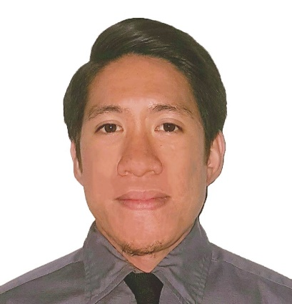

LEE

LEE.362350@2freemail.com

Computer Engineer

WORK EXPERIENCE:

Company : Joey Riley & Associate Inc. (Recruitment Firm)
Ayala Center, Cebu City, Philippines
Position Held : Data Analyst
Duration : April 6, 2015 to April 29, 2016

Professional Description:

- Assist in the collection and consolidation of required information and data
- Analyze the client's target audience, payment behaviour and history
- Track the revenue patterns of clients and alert the team for sudden fluctuations
- Investigate the possible factors that may have caused sudden changes in client revenue
- Prepare a professional, coherent, and grammatically correct business correspondence that details the investigation made and the potential resolution
- Proactively approach team members with recommended optimization methods for clients

Company : A.S. Online Consulting Inc.
Centro Fortuna, A. S. Fortuna Street, Mandaue Cebu City, Philippines
Position Held : Data Analyst
Duration : May 9, 2016 to March 3, 2017

Professional Description:

- Receive and review the sources
- Prepare the daily report following the prescribed format and guidelines
- Ensure that all articles are in their proper sections
- Communicate with designated contact person for day to day operations
- Coordinate with the team if any issues encountered in executing the processes
- Train and lead any additional team members
- Monitor daily tasks based on key performances indicators
- Build up procedures manual
- Any other tasks that falls within the same skill set that may require

PROFICIENCY & SKILLS
EDUCATIONAL ATTAINMENT:

Bachelor of Science in Computer Engineering - Programming in the following languages:
University San Jose-Recoletos (C++, Java, HTML, CSS)
Cebu City, Philippines - Knowledgeable in Software & Hardware
application
- Knowledgeable in MS Office Application
such as Word, Excel, and PowerPoint

- Video/photo editing

(Adobe Photoshop, After Effects, Premiere)

TRAININGS:

Company : Coca Cola Bottlers Philippines Inc
Duration : April 2, 2014 to May 30, 2014
Course Title : On-the Job Training (OJT)
Location : Mandaue City, Cebu, Philippines

PERSONAL DATA:

Date of Birth : September 18, 1992
Nationality : Filipino
Height : 162cm
Weight : 50 kg
Religion : Roman Catholic
Civil Status : Single
Visa Status : Tourist Visa
Visa Expiry : 15 June 2017

I certify that the above information is all true and correct. Supporting documents and character references will be given upon request.

