CURRICULAM VITAE

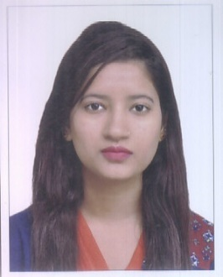
MEENAKSHI
MEENAKSHI.362412@2freemail.com
-------------------------------------------------------------------------------------------------------------------------------
OBJECTIVE
To educate the youth by understanding their taste, background and ability .To achieve performance edge through hard work and continuous learning.
QUALIFICATION
Qualification | University/Board | Completed Year | Percentage
msc (math) | guru jambheswar university | 2016 pursuing
B.ED | GGSIPU | 2014 | 82.6%
GRADUATION(MATH(H)) | Delhi university | 2013 | 60.85 %
12TH(SCIENCE STREAM) | CBSE BOARD | 2010 | 70%
10TH | CBSE BOARD | 2008 | 76.8%
EXPERIENCE
Worked as TGT Math teacher in DIRECTORATE OF EDUCATION SCHOOL from 17-11-2014 to28-02-2017
GGSSS BALI MARHAN(URDU MEDIUM) | 17-11-2014 TO 27-07-2015
BRD SKV PRASAD NAGAR | 01-08-2015 TO 28-02-2017

ADDITIONAL COURSES:-
Office Management suitefromAPTECH. | Duration: 6 Months
SKILLS KNOWN:-
- Good communication skills
- Knowledge of computer (MS Office, Excel & PowerPoint).

RESPONSIBILITIES:-
- Possess strong communication and analytical skills and have the ability to extract, interpret and present relevant information and advice to management.
- Use of aids {Math lab, smart board etc.} to give concrete idea of the concepts to the students.
- Concentrates on feedback from students.
- Keeps good relation with the students and their parents.
- Individualized student’s assessment systems implementation.
- Utilization of student’s strength and available resources.
- Providing opportunities to all learners.
- Evaluating students twice in a month and in test series.

Personal Details:-

Date of Birth : 20thOctober 1992

Languages Known : English and Hindi.

Marital Status : Married

Nationality : Indian

Religion : Hindu
Visa Status : Tourist Visa changing to Husband’s Visa

_____________________________________________________________________
I do hereby declare that the above written information is true to best of my knowledge and belief.

Date______
Place______

