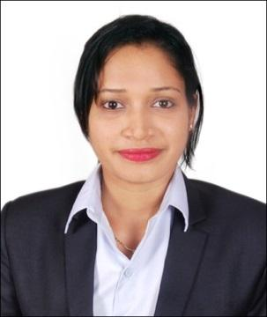

RASHMI
RASHMI.362431@2freemail.com

Career Objective:

Aiming to establish myself in the field of education and to utilize my knowledge for the betterment of students, where I can give and in turn gain knowledge.

Educational Qualification:

Qualification | Board/University | Institution | Year of | Marks (%)/
 |  |  | Completion | CGPA
M.com | Mangalore | Mangalore | 2015 | 71.31%
 |  | University,
(Finance) | University | Karnataka.
B.B.M. [Bachelor | Mangalore | K.V.S.M. College, | 2013
of Business |  |  |  | 82.22%
Management] | University | Katapady
PUC(Science) | Karnataka Board | M.G.M. PU College, | 2009 | 64.33%
[11th & 12th] |  | Udupi
SSLC | CBSE | Little Rock Indian | 2007 | 78.2%
 |  | School, Brahmavar

Project:

Successfully completed a project at Prakash retail pvt ltd, Udupi on the topic “Human Resource practices in retail industry” as a part of Post‐graduation

Computer skills:

Well versed with Windows, MS OFFICE (word, excel and PowerPoint) and internet application

Personality Traits:

- Good communication skills

- Good team player and positive attitude with leadership skills
- Self‐motivated
- Problem solving skills
- Flexibility and adaptability
- Good presentation skills
- Sincere, hardworking and punctual

Professional Experience:

Institution: Krishnabai Vasudeva Shenoy Memorial College, Katapady

Designation: Lecturer in commerce for under graduate students

Duration: one year (May 2015‐April 2016)

Responsibility:

Lecture planning and preparation

Checking and assessing student performance and work as their academic advisor Paper preparation and presentation at seminars

Organizing and managing academic as well as cultural events. Anchoring for formal events
Administrative works including student admission Invigilating examinations

Judging academic as well as cultural events Conducting Training sessions for students Organizing campus interviews

Achievements & Extra‐Curricular Activities:

Have done anchoring for various events.

Prepared and Presented papers at National and State level Conferences as well as for intercollegiate competitions.

Active member of various social groups

Conducted training sessions as a part of social organization.

Have served as the secretary of student council during under graduation Was a part of team in organizing fests and other events
Have cleared the Karnataka state Entrance Test (KSET) for lectureship examination in December 2015.

Participated in the inter‐collegiate fest and competitions and won prizes. Have won prizes in various literary and cultural competitions.

Hobbies | : Reading books, cooking, social activities, listening to music
I confirm the above furnished details are true to the best of my knowledge.

