VISHU
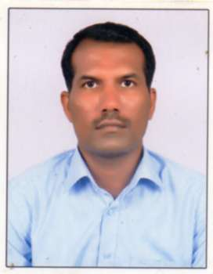
Vishu.362436@2freemail.com

OBJECTIVE

Career which gives good environment for utilizing and developing my technical and interpersonal skills.

ACADEMICS : PASSED - 2002 - 2005
Diploma - Printing technology
SCAD Polytechnic, Thirunelveli

TRAINING UNDERGONE : Coronation Litho Works limited sivakasi

Duration: 2 months

EXPERIENCE : 12 Years

INDUSTRY : Packaging India Pvt Ltd (A Unit of AMCOR)

DURATION : 14.6. 2010 to 01.08.2016

DESIGNATION : Executive in Inkkitchen

DEPARTMENT : Ink Kitchen &Production

RESPONSIBILITES HELD

- INK AND SOLVENT CONSUMPTION

- COLOUR MATCHING

- COLOUR MEASURMENT USING XRITE-NGH-500 DENSITOMETER

- Maintain ink GSM

- RK Printing Proofer

- ON LINE ERP Entery (Ramco)

INDUSTRY : DAILY THANTHI

DURATION : December 2006 – 2010

DESIGNATION : Executive

RESPONSIBILITES

- CTP dot plate checking

- Process parameters setting as per standards

- Handling experience in Goss universal 70, pneumatic control machines

- Colour measurement using XRITE Densitometer

INDUSTRY : Nagaraj Company Pvt ltd, Chennai

DURATION : 18 months

DESIGNATION : Assistant Operator

DECLARATION

I declare that the information furnished above is true to the best of my knowledg

