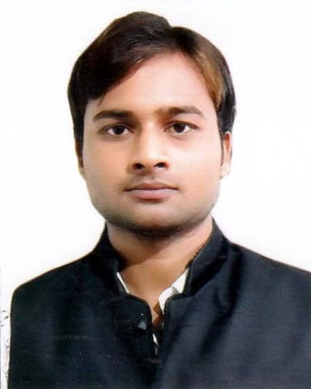
Curriculum Vitae

SAMEER
sameer.362449@2freemail.com

OBJECTIVE:
To seek challenging career in a fast place organization where my experience commensurate together with my creative approach with can contribute to its long term goals thereby helping to strength my professional skills I acquired throughout my career.

EDUCATION:
- Bachelor’s Degree from DDU (Deen Dayal Upadhyaya Gorakhpur University) India
- HSSC (Higher Secondary School Certificate) India

TECHNICAL QUALIFICATION:
- 1 year Diploma in Web Designer (HTML, Photoshop, Flash, Coral Draw, Illustrator & Dream Viewer) from S.R.ANIMATION & MULTIMEDIA in India

WORKING EXPERIENCE:
- 1 months experience in Web More Technology as a Web Designer in Delhi, India

PERSONAL DETAILS:
Date of Birth: 11/10/1997
Nationality: Indian
Marital Status: single
Gender: Male
Religion: Muslim
Languages: English & Hindi

OPERATING SYSTEMS:
- Windows XP, Windows 7, and other Computer Installation.
- MS Office (word, excel, power point).
- Internet, E mail, Fax, Scanning & Printing.
- Computer Typing

SKILLS:
- Hard-Working, Honest & dedicated
- Excellent interpersonal skill, Responsible & Reliable
- Possess excellent learning skills, superior intellectual & analytic capabilities
- Time management & Communicating
- Confident, Critical thinking perseverance

HOBBIES:
- Playing Cricket
- Singing Songs
- Reading Books
- Internet Browsing

DECLARATION:
I declare that the above particulars filled by me are correct and true to the best of my knowledge and belief. I hope that my experience will meet your requirements.

