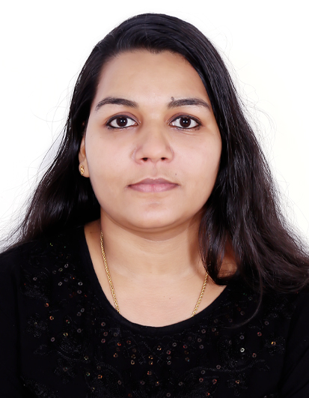
SAINA
Saina.362460@2freemail.com

Career Objectives

Ambitious to build a career in accounting and finance with an organization where team work is required and hard working is appreciated and to be in a position which is best suited to my knowledge and skills.

Academic Credentials

Course | Institution/Board | Year of Passing | Mark Scored
Masters Degree in  Commerce | IGNOU- India | 2016 | 61%
Bachelor Degree in  Commerce | Calicut University-Kerala | 2009 | 71%
Plus Two (Commerce Group) | Assumption HSS, HSE-Kerala | 2006 | 85%
SSLC | Board of Public Examination Kerala | 2004 | 79%

Computer & Software Skills

- MS OFFICE,MS EXCEL
- TALLY
- OFFICE AUTOMATION AND ACCOUNTING SOFTWARE

Training & Workshops Attended

- Attended two month spoken English training class conducted by Anglo Intelligentsia institution at Thrissur.
- Attended one day personality development program.

Personal Strength

- Flexibility and adaptability
- Positive Attitude
- Hard working
- Goal oriented

Commerce Papers Studied

- International Business Environment
- International Marketing Management
- India’s Foreign Trade
- Export Import Procedures and Documentation
- International Marketing Logistics
- International Business Finance
- Organization Theory and Behavior
- Research Methodology and Statistical Analysis
- Financial Management

Work Experience

Worked as Accounts Assistant for the period from September- 2014 to November-2015 at GOOD YEARS HIRE PURCHASE AND FINANCE AMBALLUR-THRISSUR.

