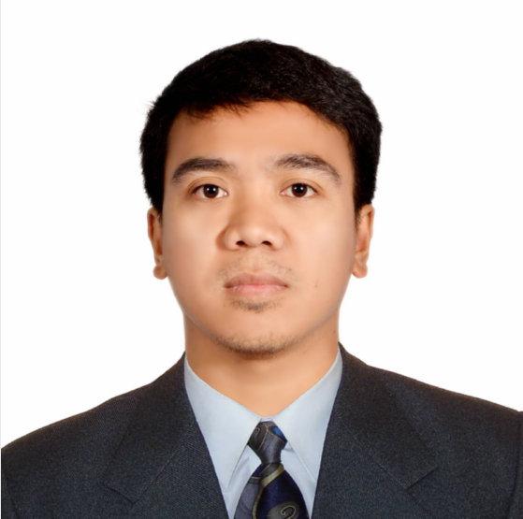
LUISITO
LUISITO.362462@2freemail.com

OBJECTIVE

Looking for a job that will suit my qualification and will establish my career in a prestigious company where experience are rich and opportunity are for all.

SKILLS

- Can Speak Arabic/English
- Autocad2014 2D/3D
- Computer Literate, Microsoft Word, Microsoft Excel
- Computer Technician
- Installing hardware and software system
- Forklift Operator

JOB EXPERIENCES

OPERATOR
Heba Fire Fighting Equipment MFG.Co.
2nd Industrial City Dammam Saudi Arabia
November 24, 2014 to January 16, 2017

MACHINES OPERATED: ABB ARM ROBOTICS & EUROMAC PUNCHING (CNC MACHINE)

“Awarded for implementing the cost reduction (Reduced monthly budget in our area)
With Certificate”

OPERATOR
Saudi Ceramics Co.
P.O Box 3893 Riyadh Saudi Arabia
December 6, 2008 to March 3, 2014

MACHINES OPERATED: Forklift, Falcon(For Palletizing), System Ceramics(For Packing),B&T (Barbieri Tarozzi), Ballmill, Spray Dryer, Kerajet/Inkjet(For Printing)

Additional Experience:

One year in office staff as COORDINATOR of Saudi citizen employees in SAUDI CERAMICS CO.’

ELECTRICAL/MECHANICAL
Samsung Philippines(semphil)
CPIP Batino,Calamba City Philippines
February 21,2007 to October 14,2008

EDUCATIONAL BACKGROUND

Vocational Course Electronics

College INFORMATION TECHNOLOGY (IT)
AMA Computer Learning Center
San Pablo City Philippines
Undergraduate

High School Alaminos National High Shool
Alaminos, Laguna Philippines
2000-2004

SHORT COURSES SCHOOL

School Course Address Year
MICROCAD Autocad 2D/3D MANILA 2014
CSM TUTORIAL CENTRE Comp.Tech. RIYADH 2011-2012

CHARACTER REFERENCES:

Available upon request

