Curriculum Vitae
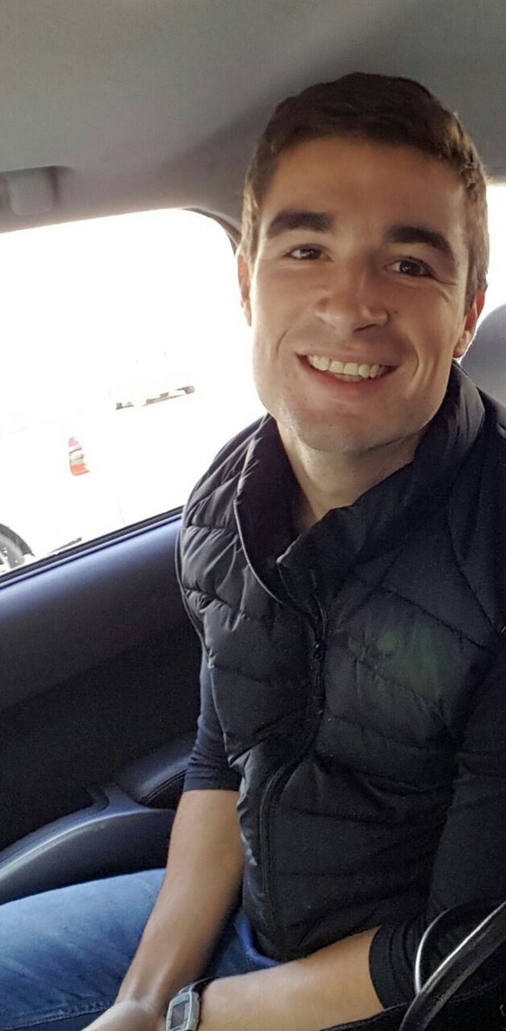
Stefan

National Diploma: Sport Management
National Certificate: Fitness

Contact details:
Stefan

Personal information:
Date of birth: 18 June 1991
Marital status: Single
Dependents: None
Drivers license: Code B
Nationality: South African
Gender: Male
Race: White
Language: Afrikaans/English
Language qualification: Afrikaans
English

Secondary education:
Schooling: Outeniqua High School (2005-2009)
Highest Grade Passed: Grade 12 (Nasional Senior Certificate)

Senior certificate:
Afrikaans Home Language
English First Additional Language
Math Literacy
Life Orientation
Business Studies
Accounting
Tourism

Leadership:
- Captain of SWD Hockey (2009)

Sport:
- Representative for school in the area of:
  - Hockey
  - Athletics
  - Golf

Sport Achievements:
- U/14 Southern Cape – Golf (2005)
- U/16 Southern Cape – Golf (2007)
- U/16 SWD – Hockey (2007)
- U/16 A Outeniqua High School – Hockey (2007)
- U/19 A Outeniqua High School - Hockey (2008)
- U/18 SWD – Hockey (2008)
- U/19 A Outeniqua High School - Hockey (2009)
- U/18 SWD – Hockey (2009)

Other:
- Lifesaving – Herolds Bay (2005-2009)

Tertiary education:
Institution: Exercise Training Academy (ETA) – Stellenbosch Campus
Qualification: National Diploma Sport management
National Certificate in Fitness
Period: 2013-2016

Leadership and management:
- Official at Cross Country events (2014)
- Hockey –Boland Barlinkas U/13 Boys (2013)
- Junior Manager – Evolve Fitness (2016)

Sport:
- Paarl mens Hockey (2013)
- CPUT USSA golf – Limpopo (2013)

Cultural:
- First Aid certificate - Level 1
- First Aid certificate - Level 2

Other:
- Promotions for Media 24 (2014)
- Promotions for First for Women (2014)
- Omruil boerdery (December 2014)
- Rooipad boerdery (Junie 2015)

Sports Coaching:
- Hockey - Paarl Gimnasium Primary U/10 A+B (2013)
- Hockey - Hugenote Primary U/13A (2013)
- Hockey - Boland Barlinkas U/13 Boys (2013)
- Hockey - Paarl Boys High U/18B (2014)
- Hockey - Paarl Gimnasium Primary U/13 A+B (2015)
- Hockey - Paarl Gimnasium High School U/18 B (2015)
- Hockey - Paarl Gimnasium Primary U/13 A+B (2016)
- Hockey - Paarl Gimnasium High School U/14 A+ B (2016)

Physical Education:
- Physical education teacher at Paarl Gimnasium Primary. (2014 – 2016)

Experience:
- Personal Trainer/Floor Instructor at Evolve Fitness. (2014 - 2015)
- Junior Manager at Evolve Fitness. (2016)

Experience:
Curricular obligations:
Practical education:
Practical education at Outeniqua Primary (2011)
Practical education at Outeniqua Primary (2012)
Practical education at Curro Durbanville Private School (2012)

.

