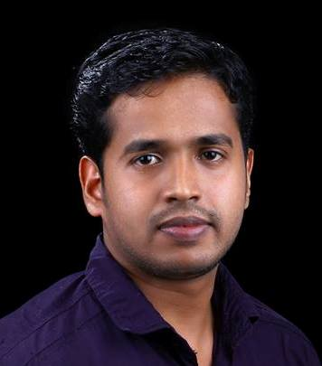
Suravind
Suravind.362510@2freemail.com

OBJECTIVE
To become a system administrator with my extensive professional background and to prove myself as a valuable asset to the organization I work.

PROFESSIONAL EXPERIENCE

AL DOBOWI GROUP Oct 2012 to till now
Position: IT Support Executive

Project: AL DOBOWI Group is a UAE based company. I am into the system support team where I need maintain server issues and system issues.

Tata Consultancy Services Oct 2011 to July2012
Position: Process associative

Project: EA Sports
Profile: Worked in an Application support team where we have to support all kinds of EA Sports Applications like GPS, GFR, Migros etc

Allied Digital Services June 2010 to September 2011
Position: Customer support engineer
Organization: Dell

Client: Indecomm Global Services, Bangalore.
Project: Indecomm Global Services is a BPO with more than 2500 employees and about 20 office premises all over India. I was part of the Support team which provides Hardware and Software support to Indecomm. I do have experience from basic hardware installations such as OS installation, Mail id creation, mail client configuration in lotus notes and outlook.

Copper Spiral RFID Technologies September 2009 to may2010
Position: System Engineer

Project: Copper spiral RFID is a RFID based company. I was into system support team where I need to do the basic trouble shooting of hardware and basic softwares and also need to test the RFID hardware’s.

PROFESSIONAL SKILLS

- Comprehensive knowledge of the following Microsoft technologies: Windows 2012 ,2008 R2 and 2003 Active Directory, Group Policy, DNS/DHCP/WINS, File & Print services, Exchange Server, Domino Server.
- Administration, Customizing the ERP software Orion 10.6
- Storage technologies (SAN, NAS, RAID, Synology), backup and Disaster Recovery.
- Networking and Security: LAN and WAN, Internet technologies, Fortigate Firewall and Web filter.
- IP Telephony, Surveillance, access control, electrical infrastructure, data center management and design.
- Ability to lead and manage a team of IT professionals.
- Ability to assess IT requirements, create IT policies, strategic plans and recommend to senior management.
- IT Compliance for ISO and other certifications
- Design, implementing, upgrade and maintain the LAN&WAN networks.
- Experience with Active Directory design and troubleshooting.
- Experience Manage Antivirus servers, Vulnerability protection and application control for Trend Micro.
- Experience in VMware.
- Install and maintain all end-user software and hardware.
- Operating System: - Professional with All Windows versions as Administrator & User.
- Experience with MAC OS, Linux System, IOS and Android.
- Application: - Expert for using Microsoft Office, Internet, E-mails & All others applications.
- Hardware: - Hardware and Software Installation, Networking, Technical and Troubleshooting PC, Smart Mobiles Phones, Tablets, Laptops and Electronic Assembly.
- Networking: - Manage and maintenance LAN, WLAN, switch, Cables, Access point and Basic Router Configuration.
- Handling of ticketing tool SUMMIT, online IT support.
- Updation and management of windows patches
- Remote support through Dame Ware, VNC and Team viewer.
- Knowledge on applications like GPS, GFR , Migros.
- Experience in Sonic wall security permissions, internet restrictions etc..,

EDUCATIONAL QUALIFICATION

- Diploma in Information Technologies from NTTF IT Centre Bangalore, Karnataka.
Specialization: Information Technology

PERSONAL DETAILS

Date of Birth : 15-10-1987
Nationality : Indian
Marital Status : Married
Languages known : English, Malayalam, Kannada and Hindi

DECLARATION

I hereby declare that the above-mentioned information is correct and very much sincere as far my knowledge.

Date:

Place: Dubai

