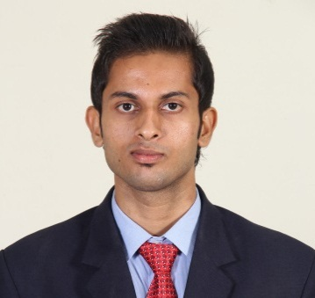
AMAL

Email: AMAL.362548@2freemail.com
Interested fields: Hr and Marketing

CAREER OBJECTIVES

To seek a challenging position in the fields of HR and MARKETING in a reputed Organization where I can utilize my abilities and skills to the maximum and get more creative stimulation & career options in the field.-
EDUCATIONAL QUALIFICATIONS

MBA in Human Resource and Marketing (2013-2015)
MARIAN INTERNATIONAL INSTITUTE OF MANAGEMENT (MIIM), Idukki

BBM in Finance (2010-2013)
ST FRANCIS DESALES COLLEGE, BANGALORE
PROFESSIONAL EXPERIENCE

NARAYANA HRUDAYALAYA Health City, Bangalore 2016January – Feb2017
HR Executive
- Coordinating for new joiners Induction and orientation
- Coordinating with internship students
- Maintaining the data bank of the candidates
- Organizing interviews
- Training the employees and conducting classes
- Managing the employees attendance and leaves on a Regular Basis
- Maintaining the Personnel files of the employees and forwarding to payroll team
- Organizing and coordinating for interviews
- Coordinating in the process of recruitment of the right number at the right time.
- Analyse and do comparative study in the process of selection
- Coordinating for the manpower approval process
- Maintaining all the records as per the statutory requirements.
- Actively participating in HR activities
- Manpower Planning and budgeting activities
- Updating the department wise manpower status
- To involve in succession planning and rationalization of manpower
- Creating of department and organization specific Job descriptions and taking forward job audits at regular intervals
- Handling post recruitment activities like joining formalities
Fiem auto Bangalore October 2016-january2016
Marketing executive
- Maintain the data base of the customers
- Achieve the monthly targets as per the company direction
- Study about the market and implement new marketing strategy
- Attend the meetings and conferences
- Maintain relationships with media vendors and publishers to ensure collaboration in promotional activities

INTERSHIP OUTLINE

2013:1 Month project in SUDHEER INTRA PVT LTD BANGALORE (UG Project)

2014: 2 Month Internship in FIEM AUTO (auto parts manufacturing organisation) BANGALORE.
Objective of the study is to acquire practical knowledge about the functioning of the organization with special reference to each department.
2015:2 month Internship In LAKESHORE HOSPITAL Kochi
Objective of the study is to know about the Causes of work stress among employees in the organization.

ACHIEVEMENTS
- Designed and Delivered monthly leadership development classes, leading to improve relationships, and better communication between the employees
- Facilitated discussion as a coach
- Maintained a good attendance record
- As a part of the jci team i had presented the seminars and PowerPoint presentations
- Attended NATIONAL seminar held in ST FRANCIS DESALES COLLEGE BANGALORE
- BEST PERFORMER in a national seminar held in SFS COLLEGE BANGALORE.
- Participated in national level management fest held in Miim and i was the coordinator for the event theme show.
PERSONAL PROFILE

Nationality : India
State : Kerala
Current place :UAE
Age : 25
Religion : Christian
Date of Birth : 23 -09-1992
Gender : Male
Marital Status : Single

LANGUAGE PROFICIENCY

Languages | Read | Write | Speak
English | Yes | Yes | Yes
Malayalam | Yes | Yes | Yes
Hindi  Kannada | Yes  No | Yes  No | No  Yes

TECHNICAL SKILLS
- Proficiencies in graphic designing
- MS Office(Exel,Word,Power point)

HOBBIES
- Driving
- Playing football
- Travelling

