Abhishek.362554@2freemail.com | 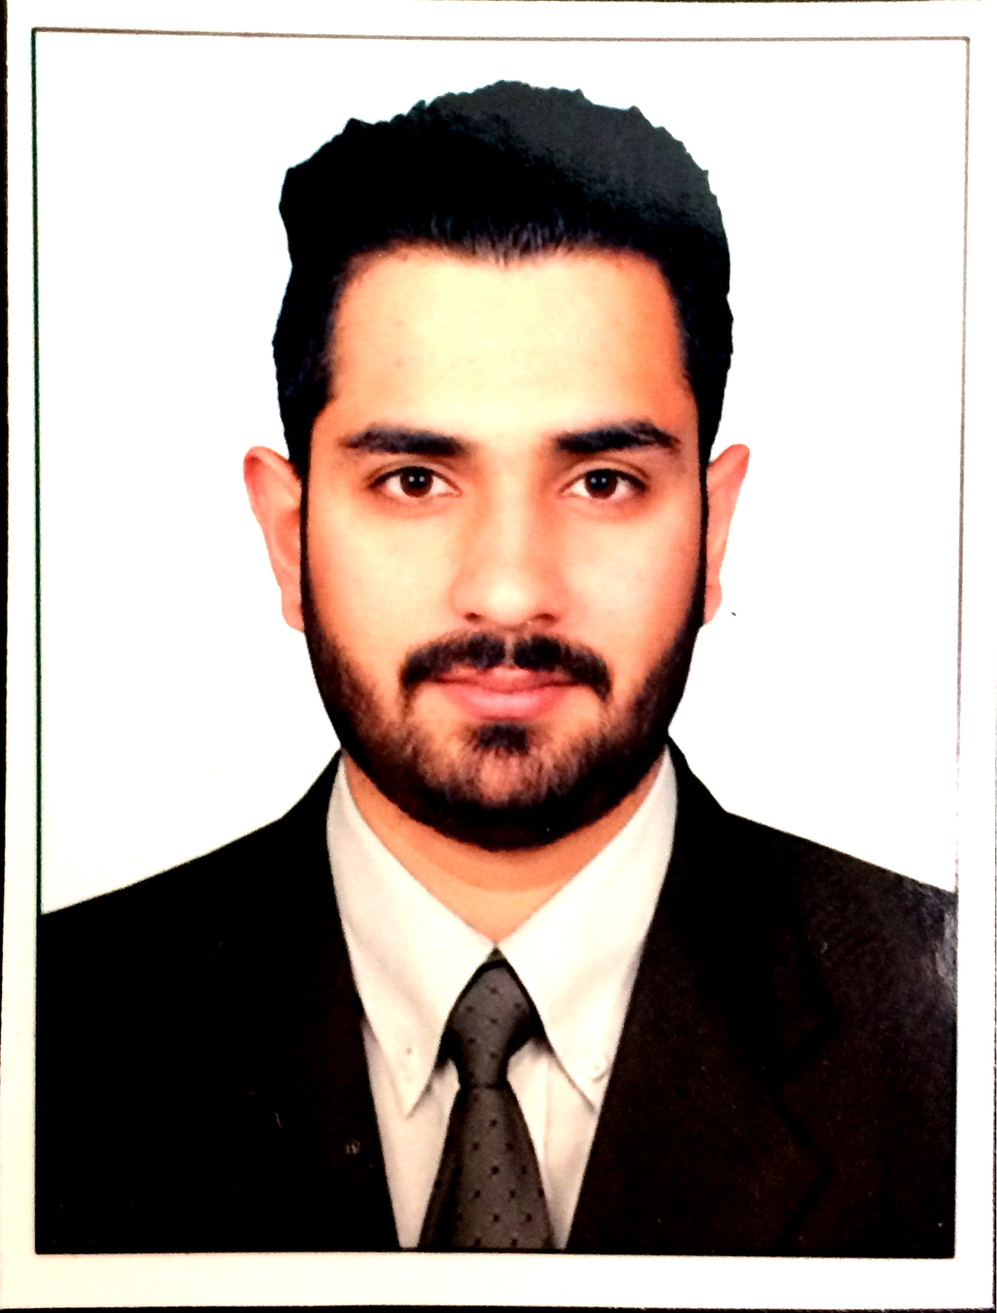

Professional Summary
A passionate Human Resource professional who wants to explore new experiences every day. Love to face challenges at work and also research work. Have experience in the field of HR-Recruitment through LinkedIn, Portals, Social media, Online search. Working for middle level & senior level requirements for product based companies in E-commerce, mobile application, internet etc.
Professional Experience 2 years of Total Experience

Associate Consultant at Wenger & Watson Inc, Bengaluru, India from October 2015 – October 2016.
- As a Recruiter, has handled the entire Recruitment Life Cycle- for all requirements right from Sourcing profiles, Screening profiles, Evaluating, Short listing candidates and Interacting with the client.
- Majorly worked on E-commerce, Product Based Companies and well funded Startups.
- Was involved in sourcing, screening, shortlisting resumes through various Recruiting sites, LinkedIn, Social Networking sites such as Twitter, etc.
- Has worked on collecting all the Information regarding the requirement and targeting folks from specific road-maps for the same.
- Has searched right profiles through Headhunting, References, LinkedIn, Job Postings and targeted mailing, database etc.
- Interacted with the candidates to explain the role, business, hierarchy, reporting and to overcome the passive mindset to excite them about the leadership opportunity.
- Has done detailed screening of the interested candidates by asking them specific set of technology/people management questions.
- Prepared a detailed write-up for the candidate to be shared with the client along with the profile.
- Scheduled Interviews as per Client’s convenience and keeping in-view candidate’s convenience.
- Was involved in getting feedback from both Client and the Candidate.
- Provided market insight to the candidates and Salary negotiation.
- Has involved in meeting up with the candidates who are offered from our clients to make sure they join them.
Technical Service Associate, MINACS, Bengaluru, India from April 2014 to March 2015
  - Provided technical services to Apple India customers. The services were related to iOSdevices - iPhone, iPad, iPod.
  - Analyzed the software glitch as per the issue and to resolve within the specified time.
  - Resolved the device issue remotely.
  - Collaborated with clients, and other technical engineers to translate software and business requirements into technical designs.
  - Handled escalation from the level 1 team. 10-15 escalation per day.
  - Followed up with the customers until their issue were resolved.
  - Achieved customer satisfaction target of 90% every month.
Clients and Positions Worked
Amazon (Global Payments Team and OLP) - Software Development Engineer – 1 and 2, Quality Assurance Engineer – 1 and 2, Software Development Engineer in Test – 2, TPM, EM.
Thoughtworks – Senior Quality Assurance Engineer, Senior Software Developer.
Boomerang Commerce – Senior Software Developer, Software Development Engineer in Test.

Education
Qualification | Board/University | Year of passing | Grade
MBA- Human Resource | Gems b school – Bharathiar University | 2015 - 2017 | Currently Pursuing
B.E-ECE | VISHWESHWARAYA TECHNOLOGY UNIVERSITY | 2014 - January | 2nd Division
Class XII | JAMMU AND KASHMIR STATE BOARD OF SCHOOL EDUCATION | 2008, Annual | 1st Division
Class X | JAMMU AND KASHMIR STATE BOARD OF SCHOOL EDUCATION | 2006, Annual | Distinction

Skills
- Recruitment, Talent Acquisition, Screening, Consulting, Sourcing, Head Hunting, Job Posting, Referencing, Mass Mailing.
- Operating Systems: Windows XP/ Vista/ 7/8.1, OS X Yosemite.
- Excel basics.
- Team Player.
- Target oriented.
Achievements
- Successfully closed important positions with the clients.
- Participated in the Recruitathon an quarterly event conducted by LinkedIn in Wenger & Watson.
- Promoted to a Senior Advisory role after 4 months of joining the company (Minacs).
- Successively achieved the monthly targets assigned by the team leader.
- Have volunteered in number of blood donation camp.
Interest
Playing Cricket and Football, Cooking and watching football.

Reference To be provided on request.

