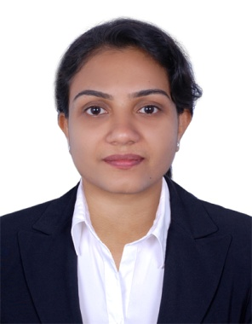
Lini
Lini.362557@2freemail.com

Career Objective:
To employ my knowledge and experience with the intention of securing a professional career in Accounts with opportunity for challenges and career advancement, while gaining knowledge of new skills and expertise.

Summary:
MBA (Madras University), M.Com from Madurai Kamraj University Post Graduate with 3+ years of Accounting Career in Apparels Export/ Finance Pvt Ltd/Automobile Industry
Skills:
Book keeping, Journal, Ledger, Accounts Receivable/Payable, Petty Cash Management, Bank Reconciliations, Profit & Loss Balance Sheet, Good Analytical Skills

Academic Qualification:
- MBA - Finance Post Graduate from Madras University -2014
- M.Com from Madurai Kamraj University - 2007
- BCom from Calicut University – 2003

Certifications:

Course : Accounting (Tally6.3,7.2, tally9)
(Government of Kerala (STED project))
Course : Office automation (MS Office)
Course : Type writing Lower
(Government of Kerala)

Professional Experience:
Maruti Suzuki Dealer (July 2016 – Present)
Back Office Assistant

Job Profile:
- Compile receipts and update cash book
- Data entry
- Preparation of BRS
- Supporting Insurance Department in Premium Calculation, endorsement, break in renewal
- Handling Customer queries on Insurance details

Sree Gokulam Chit & Finance Pvt , Chennai Corporate Office (July 2008 – March 2009)
Accountant:

Reporting to Finance Manager
Job Profile:
- Preparation of various books like ledgers, petty cash book,cash book,bank book, BRS etc….
- Handling tally process of cash book,bank statement and collection statement.
- Handling fixed deposits and staff security deposits for clients in 230 branches all over India.
- Issuing of Fixed deposit receipts based on the amount ,duration and other relavant information of the client.
- Calculation of interest amount for each client based on the fixed amount
- Filing of TDS , form 15 G/H based on client’s annual income.
- Liasing with other branches on a daily basis related to client queries and solving issues

Unitex Fashions Apparels, Chennai (Nov 2006 – June 2008)
Accountant

Reporting to Finance Manager
- Preparation of daily Cash receipts and payments
- Maintenance of day today Petty cash.
- Coordinate to complete Monthly Bank Reconciliation Statements of all bank accounts maintained
- Maintenance of asset records
- Compile receipts and update cash book
- Working with spreadsheets, sales and purchase ledgers and journals

Personal Profile:

D.O.B: 18.05.1982
Gender: Female
Nationality: Indian
Father’s Name: Stanley Richardson
Visa Status: Visit Visa (till 30th June 2017)

