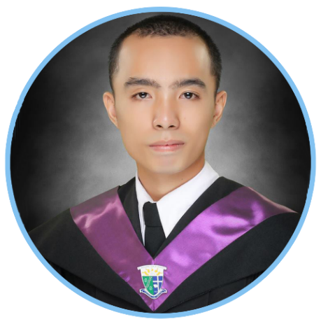

**DANHILL**

BS Information Technology

[**DANHILL.362576@2freemail.com**](mailto:DANHILL.362576@2freemail.com)

|  |  |
| --- | --- |
| **CARRER OBJECTIVES** |  |

To succeed in an environment of growth and excellence and earn a job which provide me job satisfaction and self-development and help me achieve personal as well as organizational goals.

|  |  |
| --- | --- |
| **SUMMARY OF QUALIFICATION** |  |

* Proficient with Microsoft office suite, including word Excel and PowerPoint.
* Knowledgeable in HR Admin and Sourcing work.
* Ability to work on own initiative, organize, prioritize, work under pressure, and heavy work load.
* Computer savvy and skills in installing various applications, operating systems and networking.
* Ability to organize, prioritize and work under extreme work pressure, heavy work load and deadlines.
* Flexible in both office and field works.
* Team player that able to work with other in fast faced, dynamic environment and in efficient manner.
* Experienced in retail, data and inventory handling.
* Good communication and analytical skills.

|  |  |
| --- | --- |
| **EXPERIENCES** |  |

* **Sales, Cashier and Technician**

Dreamworqz Computer Sales and Services

Cabadbaran City, Philippines

November 2015- March 2017

* Greet customers, Help and ask what they want; take customers’ order and/or concern; receive customer’s payment and unit for repair; including printers, computers, mobile phones.
* Served as additional technician if needed; do home service if requested by customer.
* Perform photo, video editing, and graphic designing if requested by clients.
* **I.T Specialist**

Condoza Software Solutions Corporations

Cabadbaran City, Philippines

August 2014 to September 2015

* Performing office works: filling, scanning and data entry in both Microsoft Excel and Microsoft word; making visual presentation using Microsoft office.
* Helps maintain Network, CCTV, Software and Hardware functionality; respond to client’s complaints for fix and installation of client’s network, CCTV, Software and Hardware. Taking calls thru PTT radio and telephone.
* Conduct physical inventory count of hardware supplies, equipment and submit status report to project manager.
* Assisting in conducting of presentation of proposal for possible client.
* Search and gather information for possible next clients.
* Handles other task given by superior
* **Part time Freelancer Computer Technician**

Cabadbaran City, Philippines

2008- 2017

* Respond and fix clients computer hardware and software problem and possible cause.
* Provide technical and analytical support.
* Provide estimate of what client need.
* Provide computer networking, software, hardware installation.
* **Human Resource Intern**

Convergys BPO Company

i2 Building, Jose Maria del Mar St, Cebu City, Philippines

April 2013 to June 2013

* Performing office work and job posting.
* Given a task to prescreen, and follow-up applicants.
* Distributes possible applicants from the pool to HR-Recruitment staff for interview.
* Inform candidate agents for benefits of Employee Referral Program and department freebies.

|  |  |
| --- | --- |
| **EDUCATION** |  |

* **College**

Bachelor of Science in Information Technology- March 2014

Father Saturnino Urios University, Butuan City, Philippines

* **Vocational Course**

Electrical Installation and Maintenance NCII- May 2016- July 2016

Technical Education and Skills Development Authority (TESDA), Cabadbaran City, Philippines

|  |  |
| --- | --- |
| **AFFILATION AND INVOLVEMENT** |  |

* **Junior Philippine Computer Society** 2009-2014

Member

* **Under Secretary** 2013-2014

College of Computer Studies Program

* **Quantum and Information Technology Convention** -2011

Maximizing the Potential of Information Technology for Economic Development

Surigao City, Philippines

Delegate

* **Make I.T Move** - January 20, 2012

Move Onward, Venture and Explore

Caraga State University, Butuan City, Philippines

Delegate

|  |  |
| --- | --- |
| **TRAININGS** |  |

* **Protective Services, Safety, Health, Environment and Disaster Management System**  - May 28, 2015

Condoza Software Solutions Corporation and Local Goverment Unit of Cabadbaran City.

Cabadbaran City Hall, Cabadbaran City

* **Electrical Installation and Maintenance**

TESDA: Provincial Training Center, Cabadbaran City, Philippines

|  |  |
| --- | --- |
| **PERSONAL PROFILE** |  |

Date of birth: October 24, 1991

Nationality: Filipino

Marital Status: Single

Visa: Visit Visa

Expiration: June 2017

|  |  |
| --- | --- |
| **SKILLS** |  |

Computer hardware and software installation troubleshooting.

Computer Networking

CCTV and electrical installation

Microsoft office

Photoshop

Microsoft Visual Basic

HTML, CSS, PHP Scripting

Admin work

Time management

Adaptability

|  |  |
| --- | --- |
| **REFERENCES** |  |

Available upon request.