Yulia
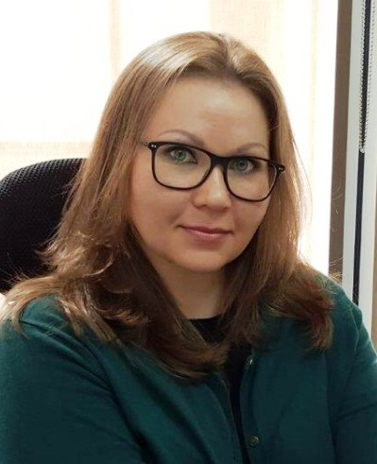
Yulia.362590@2freemail.com

Professional Summary
An Administrative professional with over 11 years of experience across UAE and Kyrgyzstan. Strong background within Oil&Gas and Construction industries. Expertise in office management, travel management, communication, business correspondence and documentation, cost saving. Determined to implement earned skills and knowledge for the growth of the company while providing a diverse administrative support.
Skills

- Ability to quickly assess and prioritize office tasks
- Excellent administration skills
- Reliable and trustworthy
- Multi-tasking and result-oriented
- Time management
- Communication and organizational skills
- Quick adaptability to changes
- Relationship Building
- Preparing reports / document translation
- An eye for detail
- Ability to work under pressure and to tight deadlines
- Analytical and problem solving skills

Employment History

UNAOIL Group of Companies, Dubai Jan., 2011 to Present
Administration Manager

- Organize and control day to day activities of the office, including personnel management, overseeing office equipment operation, processing paperwork, monitoring reception;

- Arrange local and international travel for company’s staff, management, Board Members; preparing of NOC and other documents for travel and visas; on time visa applications, flight and hotel reservation, airport transfers, transportation as and when required;

- Estimate, budget and observe office administration expenditures, including procurement of stationery, printing materials, pantry supplies, office maintenance services and allocate expenses to the relevant account;

- Ensure cost saving by elimination of overcharges, defining unnecessary services, rate reduction from providers through negotiation and effective communication;

- Organize office layout, planning optimal utilization of office space and storage; coordinating and supervising office relocation;

- Manage performance and provide guidance to admin staff members, carry out appraisals and disciplining staff;

- Arrange and coordinate office meetings, off-site meetings and events including hiring catering services, arrangement of meeting space, working with hotels to secure rates and availability, liaising with parties to ensure attendance;
Ceres Group of Companies LLC, Dubai Jan., 2010 – Sept., 2010
Personal Assistant to Managing Director cum Estimator

- Assist MD to prepare estimation and specifications for new construction projects;

- Filter mails, highlight urgent correspondence and print attachments; answer telephone/email inquiries and provide requested information to clients;

- Take, type and distribute Minutes of the meeting;

- Ensure MD is briefed and prepared for a meeting;

- Keep and maintain an accurate record of papers and electronic correspondence on behalf of MD;
- Prepare and register contract agreements and quotations for clients;
- Coordinate with team of designers scope of works for new projects;
- Calculate and prepare tender submissions from architects drawings and detailed specifications provided by clients;

- Deal with relevant authorities/ developers to obtain required permits and access to project sites;

Britany Pool LLC, Dubai May, 2009 – Jan., 2010
Personal Assistant to Administration Director/ Secretary

- Receive and screen office calls and visitors, schedule and set up appointments, send fax transmittals;

- Sort and route mail; arrange courier pick-up and delivery domestic/international and track delivery;

- Draft, type business letters and emails;

- Photocopying, binding documents when required;

- Maintain Master document register of contracts, documents, tender drawings, revised drawings, transmittals and all soft copies related to construction projects;

- Responsible for receiving, registering, distributing and controlling of all types of internal and external official documents;

- Recording document flow to and from all clients, sub-contractors, also issuing transmittal letters and receipts;

- Performing other tasks as assigned by the management

Bait Al Khair General Trading LLC, Dubai Sept., 2007 – Sept., 2008
Office Manager / Logistics Coordinator

- Coordinate and track movement of goods to the warehouse, ensure that goods are timely shipped and transported via rail, barges and trucks to the destination port;

- Track shipments from pick up to delivery, provide reports to customers on request and liaising with them when necessary;

- Prepare paperwork for billing invoices to clients;

- Ensure fulfillment of custom formalities for shipments re-export;

- Perform basic accounting, i.e. issuing receipts, maintain cash flow;

- Maintain filing system, organize storage of hard copy and electronic documentation;

- Supervise office and kitchen supplies, maintain office premises;

Turkish-Kyrgyz “Alis Lider” Co. Ltd., Bishkek, Kyrgyzstan Sept., 2005 – Aug., 2007
Procurement Assistant cum Interpreter /Translator (Chinese-Russian)

- Observe inventory level of material at warehouse in line with forecasts, monitor procurement schedule and supply of goods;
- Research and provide accurate product information to the management;
- Implement purchase process from searching new suppliers to negotiations and signing contracts;
- Maintain hard and electronic copies of suppliers contracts, quotations, purchase orders and quantity survey;
- Produce weekly or monthly reports for company’s management;
- Provide written interpretation of contract agreements, purchase orders and goods specifications;
- Ensure that all written translations conform the original text in terms of technicality;
- Perform oral interpretation services during meetings with overseas suppliers;
- Contributed in successful installation and launching of PVC production line at company’s factory being intermediary between representatives of the overseas supplier and local management;

Educational Qualifications

Master in International Relations, June 2004 (Diploma with Honors)
Kyrgyz-Russian Slavic University
Bishkek, Kyrgyzstan

Bachelor of Political Science, June 2003 (Diploma with Honors)
Kyrgyz-Russian Slavic University
Bishkek, Kyrgyzstan

Languages Known

English (Read, Write, Speak)
Russian (Read, Write, Speak)
Chinese (Read, Write, Speak) [Learned at the Chinese Language School from September 2004 to July 2005, Lanzhou University of China, Lanzhou City, Gansu Province – China]

Computer Proficiency

Well versed with MS Office (Word, Excel, Power Point), Outlook, Good Internet skills

Personal Details
Date of Birth - 29/04/1982
Nationality - Kyrgyz Republic
Marital Status - Single
Visa Status - Employment Visa valid till 04/12/2018
Driving License - UAE Driving License available
Interests - Sport, Travelling, Cooking, Reading

References:
Available upon request

