Curriculum Vitae

Kelwin
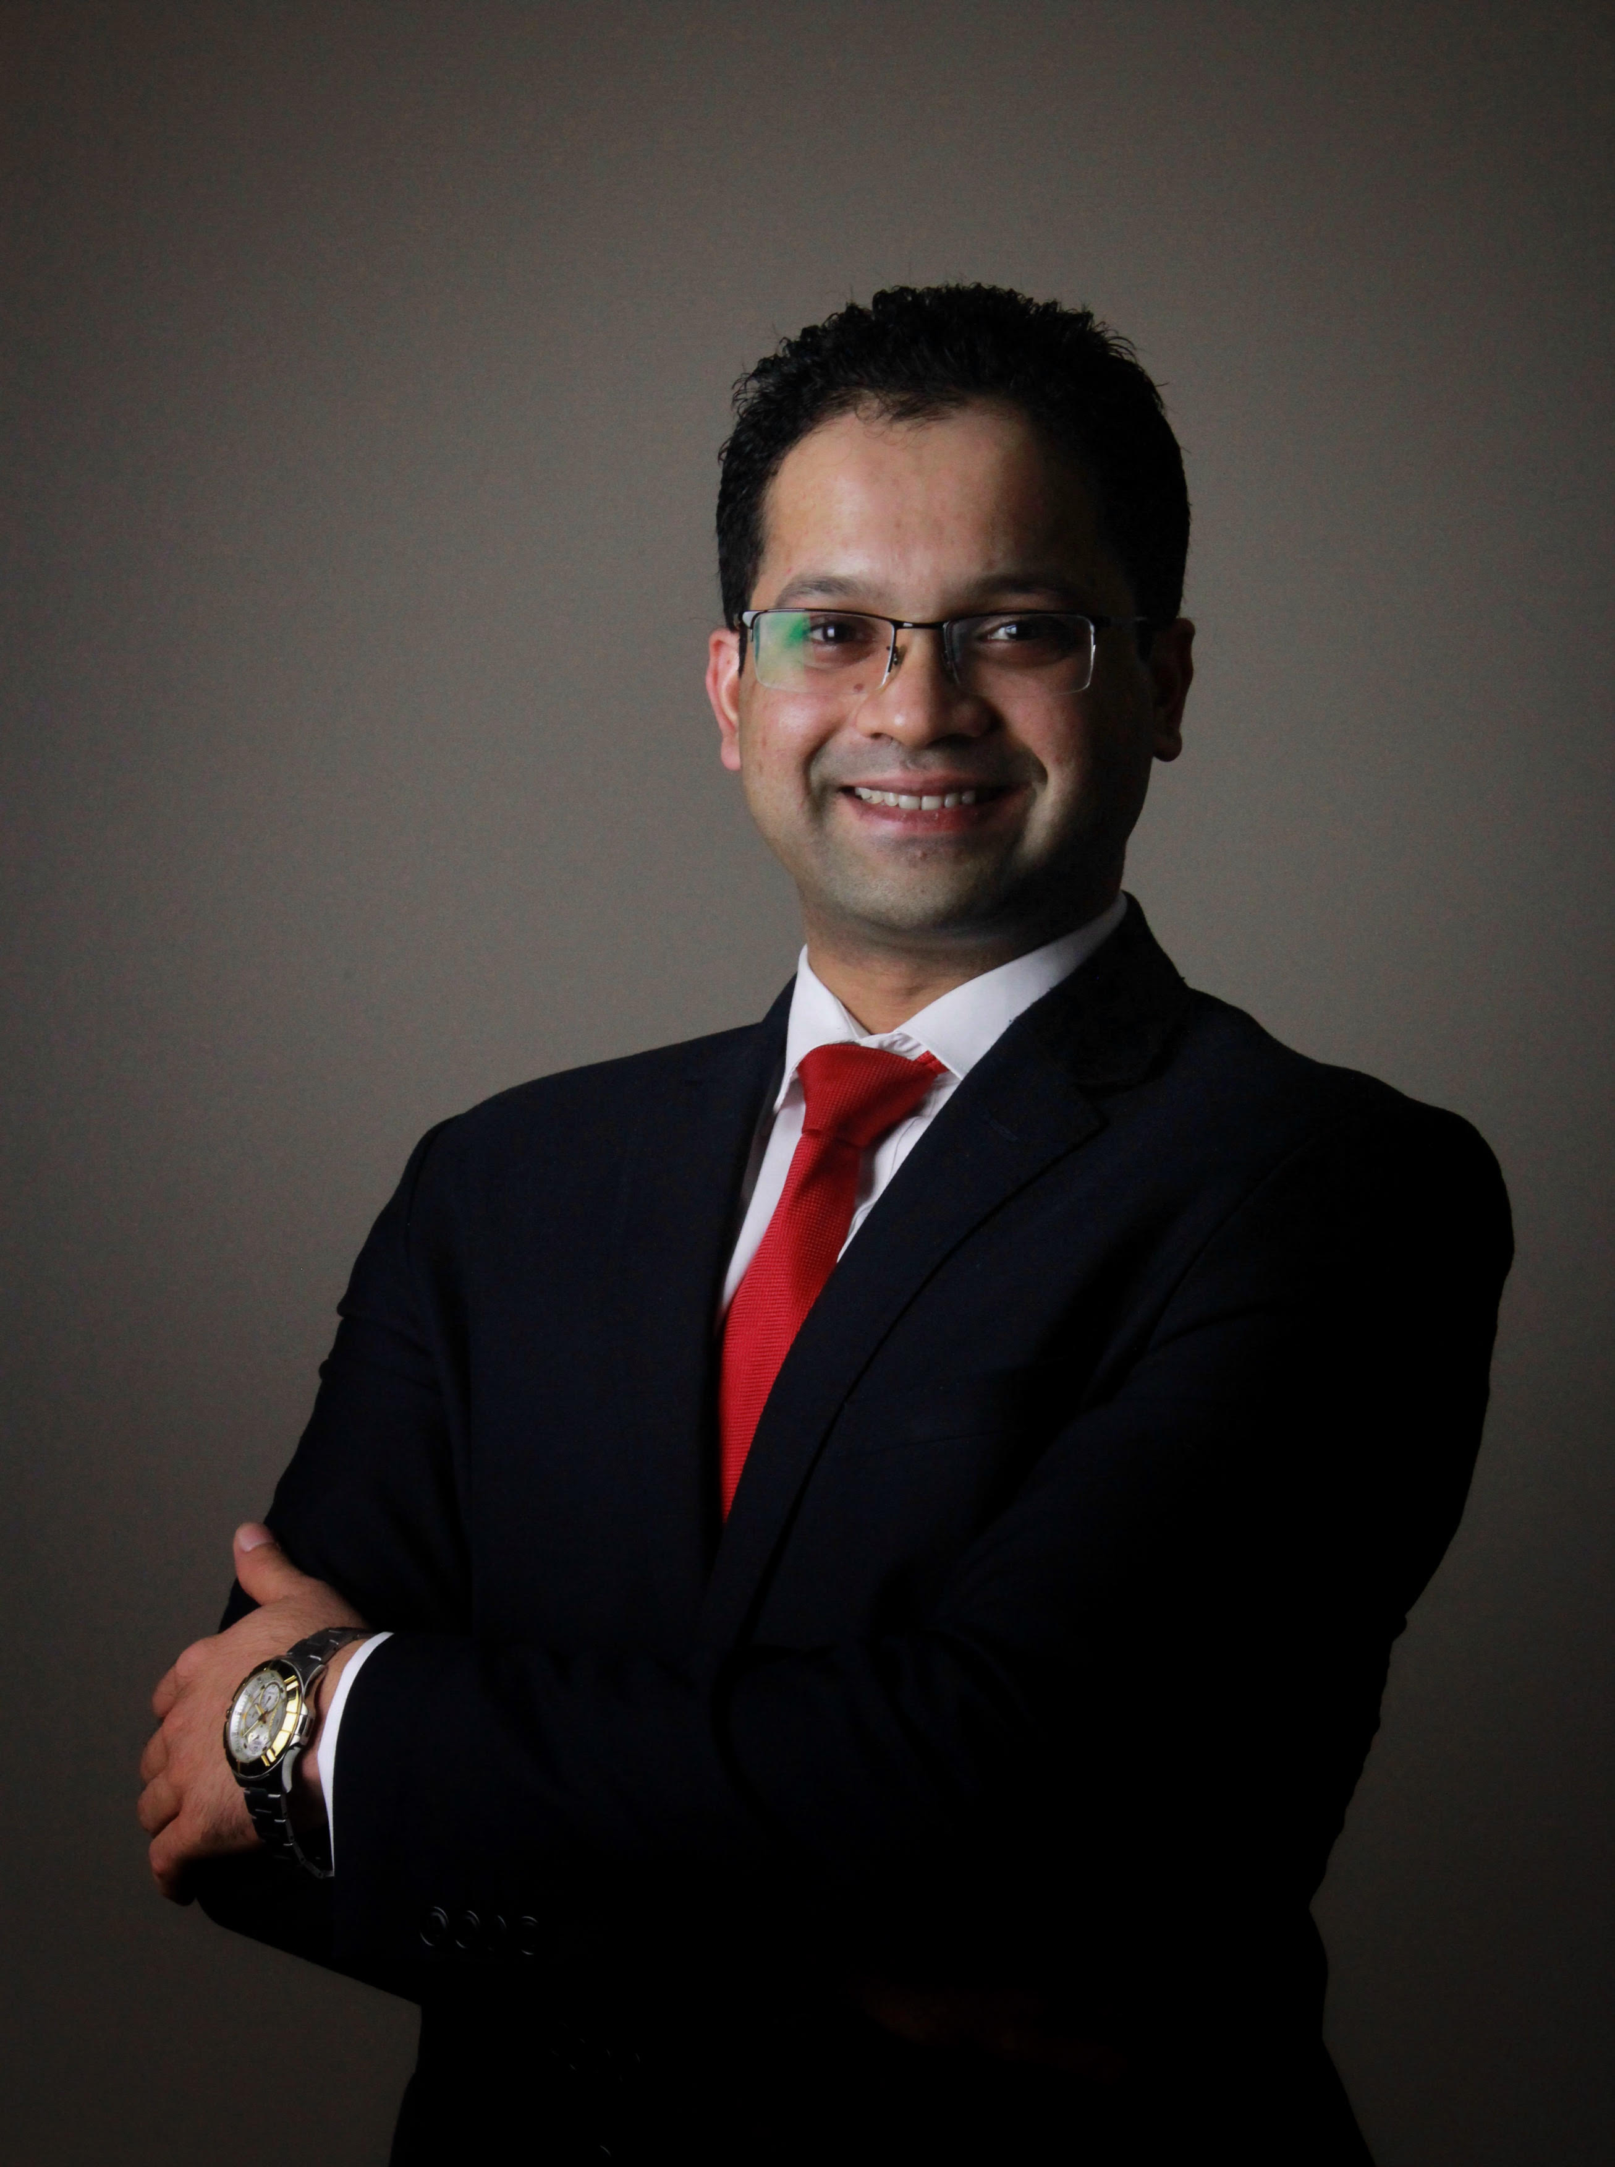

Email: Kelwin.362594@2freemail.com

Summary:
“Result orientated hospitality industry professional with management experience in high end international hotels. Established leadership skills in large operations and multi cultural environments focusing on highest service standards delivery, achieving profitability and leading market share.”

RELEVANT EXPERIENCE

Restaurant Manager | Crossroads Kitchen - All Day Dining
Marriott Marquis City Center Doha Hotel
Doha, Qatar | May 2014 to December 2016
Key Achievements:
- Nominated for SABRE awards (Service Awards for Bar and Restaurant Excellence) 2015 within Marriott International Middle East and Africa region for driving Food and Beverage
- Accomplished winning the first award for the restaurant: Fact dining awards for the "Best International Restaurant" in Doha 2015.
- Effective in planning and organizing Food Festivals to maximize revenue and gain marketing exposure.
- Initiated and Owned the Multi-outlet food promotion involving 4 restaurants to launch the “First-ever” Country Culinary Week.
- Winner of "Certificate of Excellence-2015" for Tripadvisor, with the outlet being listed on the Top 10 in Doha 2015
- Active involvement in the re-branding from the tri-pack of "Renaissance + Courtyard + Marriott Executive Apartments" to the first in Middle East "Marriott Marquis"
- guestVoice champion in FnB to drive scores in GSS (Guest Satisfaction Survey) and driving guest satisfaction scores amongst 10 Food and Beverage restaurants in t Marriott Marquis.
- Committee member representing FnB to drive service excellence within the hotel.
- Enhanced Employee Satisfaction by implementing policies and procedures within the Restaurant.
- Conduct periodical competition checks within the region. Suggest pricing change based on it.
- Implemented 4 weekly theme nights in the All Day Dining to increase revenue and add options to the in-house guests.

Restaurant Manager | La Terraza -All Day Dining
Hilton Hotel
Abu Dhabi, UAE | February 2013 to August 2013
Key Achievements:
- Conducted 2 Food Festivals – Australian food Festival and Malaysian food Festival in collaboration with the respective Embassies.
- Accomplished achieving the highest guest satisfaction scores for the restaurant.

Assistant Outlets Manager | Saray Coffee Lobby Lounge and Chopin Piano Bar
Divan Hotel | Pre-Opening experience
Erbil, Kurdistan | September 2011 to September 2012
Key Responsibilities:
- Conducted the “Grand Opening” of the hotel keeping in my outlet and ensured everything in the event went through smoothly and efficiently.
- Supervising the work of Associates, making appropriate rosters and conduct daily briefing.
- Responsible for implementing and maintaining systems of service to minimize guest complaints and maximize sales.
- Participate in service and takes special care of VIP’s.
- Communicate effectively at all levels.
- Prepare training plans and goal settings as directed by hotel policies and standards.
- Responsible for training employees to perform required standards.
- Conduct yearly appraisals for restaurant employees.
- Co-ordinate functions and activities with other outlets when required.
- Responsible for making sure food and beverage items are dispensed to guests in accordance with standards and guest satisfaction.
- Participate in training sessions and meetings as required.

Food and Beverage Supervisor
Millennium & Copthorne Hotels
London Gatwick |March 2008 to October 2010
Key responsibilities:
- To ensure smooth service in the 2 Rossette “Lion D’Or” restaurant; making sure every guest is more than satisfied with their meal experience.
- Launched various “Meal Deals” in the White Swan Pub to enhance revenue and the Average Food+Beverage Spend.
- To ensure that the highest standards of service are maintained in the Food and beverage outlets.
- To be responsible for the beverage stock and be fully accountable for any discrepancies.
- To assist the Food and Beverage Manager to achieve all departmental goals and targets.
Main duties:
- To liaise with cost control to ensure the beverage stock is kept the right level and to ensure that all beverages on sale are available at all times.
- To do the Duty Manager shifts as allocated by the Hotel Manager.
- To come-up with promotions to run in the bars/restaurants to enhance the revenue.
- To conduct various training sessions with the staff during the staff meetings.
- To look after the respective departments, i.e. Restaurant/ Bars/ Meetings and Events, when the managers on holiday or in his/her absence.
- To deal effectively customers at all times.
- To train and develop each existing or new member of staff to ensure that consistency of service is maintained.
- To ensure that customer complaints are handled correctly and followed up.

Restaurant Shift Leader | All Day Dining + Room Service
Marriott’s Hotels
Manchester Airport | December 2007 till February 2008
Key Responsibilities:
- Promoted to the Restaurant Shift Leader.
- Ensuring smooth functioning of the restaurant in the manager’s absence.
- Training the new staff.
- Maintaining the standards and ensure guest satisfaction.
- Dealing with customer complaints and ensuring guest satisfaction.

Food & Beverage Assistant| Marriott Hotels|
Manchester Airport | December 2006 till December 2007
Main Duties:
- Initially worked as a part of a busy room service team.
- In the latter part was transferred into the restaurant.

Food & Beverage Assistant| Mount Murray Hotel & Country Club|
Isle of Man, British Isles | February 2006 till November 2006
Main Duties:
- Worked part-time in this 90 bed-roomed country house and golf club which consisted of 2 restaurants, 1 bar and 2 function rooms.
- Predominantly worked during dinner shifts in the restaurant and for busy functions.

Food & Beverage Assistant|Taj group of Hotels|
Mumbai, India| June 2005 to November 2005
Main duties:
- Was a part of the Taj hospitality trainee programme in which I had an opportunity to work in “Thai Pavilion”-A fine dining restaurant, “Trattoria”- The 24-hour coffee shop, “Konkan Kinara”- The Indian restaurant specialising in west coastal meals and the Banquets which catered for functions upto 1000 pax.
- Was trained in the functioning of the Food and Beverage outlets.
- Serving the guests ensuring the highest level of standards is achieved.
- Being a part of a busy restaurant in dinner shifts and also busy functions.

summary of Qualifications

Year of passing | Course | Specialisation | Institution/ University
2005 | DIPLOMA IN HOTEL MANAGEMENT | FOOD & BEVERAGE | MAHARASTRA STATE BOARD OF TECHNICAL EDUCATION
2002 | 10+2 | COMMERCE | MUMBAI UNIVERSITY

training

- Marriott Core Management Trainings
- 5 Choices of Extraordinary Productivity
- 7 Habits of Highly Effective People
- Crucial Conversations
- Foundations of Leadership
- TOPPS (Training for On-Property Programs)
- ESSM (Essential Skills for Supervisors and Managers)
- “Train the trainer” Coaching for Star Performance by Bob Brown – Up selling techniques.
- Completed the “Essential Food Safety” Training with regards to Hygiene and Sanitation in F & B.
- Completed the “RevMax” training for up selling.
- Attended Disability training in Copthorne Hotels in September 2009
- Level 2 award in Food Safety Catering.
- Fire Marshall Training.
- Trained in Handling Duty Manager Shifts.
- Certified “First Aider” in Dian Hotel, Erbil
- Trained in “Bomb Threat”

REFERENCES

To be provided upon request.

