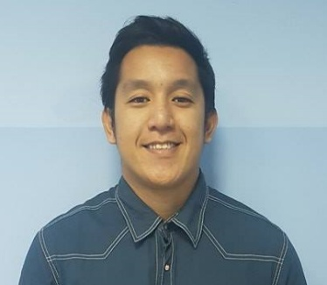

JACRISTOFFERSON
JACRISTOFFERSON.362610@2freemail.com

R E S U M E

OBJECTIVE
To obtain a job in a customer-oriented environment
SUMMARY OF QUALIFICATIONS
Ability to deal with people
Providing customer with the quality service
Experience in hands-on computer encoding
Respect to one’s duty
Can speak English
Compliance to company policies and goals

PERSONAL DETAILS
Date of Birth : December 16, 1989
Age : 27 yrs old

Nationality : Filipino
Gender : Male
Civil Status : Single
Religion : Church of Christ

April 2010
Computer Programing
Japanese School of Advance Technology
Bacoor, Cavite

2007-2008
Jedidah Christian Academy
Imus, Cavite

2003-2004
Mabolo Elementary School
Bacoor, Cavite

WORK HISTORY

April 2013 up April 4 2017
As Admin Staff/Senior Front Desk Officer
Alexandria Specialist Medical Center
Al Khoudh, Muscat, Oman
Store Keeper
Khalid Company for Medical Supplies
Al Khoud, Muscat, Oman

Responsibilities:
Attending customer needs
Verifying identification and signing in customers.
Answering phones, greeting customers and clients scheduling appointments.
Acting as a liaison between clients and executive staff.
Performs daily IT – related office work like preparation and generation of reports in Excel spreadsheets
Encoding letters/communications in Word documents.
Troubleshooting computer problems.

