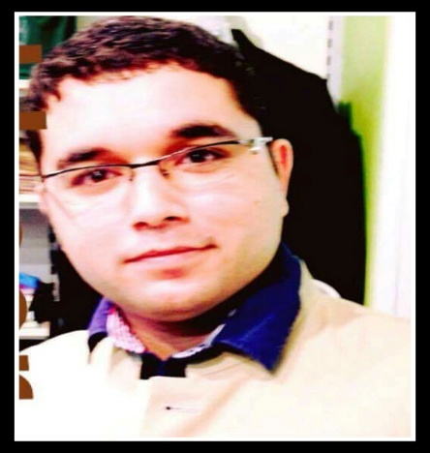

**Umer**

**Email Add:** [**umer.362629@2freemail.com**](mailto:umer.362629@2freemail.com)

**Experience:**

**Captain**

* **Beach Roatna hotel abudahbi 2015 to 2017**

**Duties and Responsibilities:**

* and responsibilities assigned by immediate superior, which leads to guest satisfaction and profit Responsible for guiding the hostess, waiter and waitress in the perform of their jobs.
* Responsible for ensuring sufficient operating guest supplies,beverage supplies and operating equipment
* Responsible for the over all sanitation and cleanliness of the outlet during the shift .
* Responsible for the proper maintenance and good working order of all equipment furniture and fixtures in the outlet .
* Responsible for consistently implementing the service standards and operating procedures in the outlet .
* Responsible for ensuring sufficiency of manpower in the shift .
* Performs other duties for the hotel .
* Must have some familiarity with basic cooking skills.

**Work**

**Career Summary:**

A highly resourceful, competent, flexible, enthusiastic, and proactive individual with considerable amount of knowledge concerning hotel’s service and hospitality with more than 3 years of experience local and overseas. Trained to work in a complex and busy hotel environment. Well organized, accurate and a quick learner. Reliable and able to establish good relationship with different people as I have frequent reaction with other guests which developed me into an ambassador for your establishment, and key to ensuring guest safety and satisfaction.

Currently looking for a career advancement opportunity as a head waiter in this prestigious hotel that will allow me to develop my skills and potentials further.

**HOUSE KEEPING SUPERVISOR**

* **ZENITH HOTEL, MALAYSIA**

**2010-2012**

* Assigns workers their duties and inspects work for conformance to prescribed standards of cleanliness
* Investigates complaints regarding housekeeping service and equipment, and takes corrective action
* Obtains list of rooms to be cleaned immediately and list of prospective check-outs or discharges to prepare work assignments
* Coordinates work activities among departments
* Conducts orientation training and in-service training to explain policies, work procedures, and to demonstrate use and maintenance of equipment
* Inventories stock to ensure adequate supplies
* Evaluates records to forecast department personnel requirements
* Makes recommendations to improve service and ensure more efficient operation
* Prepares reports concerning room occupancy, payroll, and department expenses
* Establishes standards and procedures for work of housekeeping staff
* Advises manager, desk clerk, or admitting personnel of rooms ready for occupancy
* Records data regarding work assignments, personnel actions, and time cards, and prepares periodic reports

**waiter**

* **MOVENPICK, SAUDI ARABIA**

**2012-2015**

* Greets guests and presents them with the menu.
* Informs guests about the special items and suggests food and beverages to the guest and also try to upsell
* Take food and beverage orders from the guest on the order taking pads or on the handheld Point of sale ( POS ) system.
* Obtaining revenues, issuing receipts, accepting payments, returning the change.
* Performing basic cleaning tasks as needed or directed by supervisor.
* Punch the order on the POS machine and make sure to enter the special requirements made by the guest while ordering the food. Eg: No Garlic, less spicy etc, Without egg etc.
* Communicate to the guest and provide assistance with their queries.
* Co - ordinate with the busperson, kitchen staff, bar staff to ensure smooth operation and guest satisfaction.
* Must have some familiarity with basic cooking skills.

**Personal Details:**

Date of Birth:

**March 16, 1990**

Place of Birth:

**Pakistan**

Gender:

**Male**

Nationality: **Pakistan**

Civil Status:

**Single**

Denomination:

**Muslim**

Visa Status:

**Citizen**

Currently Employed at:

**Beach Rotana Hotel**

Employment Status:

**Full Time**

***I solemnly declare that the above mentioned are correct and up to best of my knowledge.References are available on your request.***

**Sincerely yours,**

***_______________________________________***

**Academic Qualification:**

**Bachelor’s Degree**

**History of Islamic**

**Hafiz Quran + Arabic Course + English Language**

**Islamic University**

**Rawalpindi, Pakistan**

**June 2008**

**Personal Skills:**

Flexible and approachable

Attention to details

Proactive and hardworking

Punctual and reliable

Time Management

Can speak English and Arabic