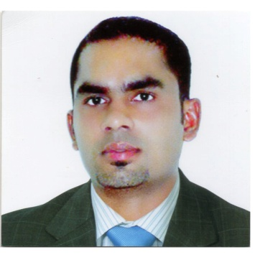

Rijas
rijas.362641@2freemail.com

APPLYING FOR : STORE/STOREKEEPER!

OBJACTIVE!
- To enhance and utilize my skills a competent worker and make most out of my abilities that I have gained through my experience. Good service is no longer enough in a fast growing business. You need a person who is hard-working, strategic, well determined, and have an excellent personality and a quick-learner to push your business to your clients.

Personal Particulars!

- Visa Status : Visit Visa
- Gender : Male
- Date of Birth : 20th April 1983
- Civil Status : Married
- Height : 5`7
- Citizenship : Indian
- Place of Birth : Kerala,Kochi
- Religion : Islam, Muslim.

Experience!

- Company name : Al Nawras Hospitality(Sharjah Golf & Shooting Club)
- Location : Sharjah, UAE.
- Position Title : Sr.Storekeeper
- Department : Store
- Duration : 2009 to 2013

- Company name : Orok Auto parts
- Location : Dubai,UAE.
- Position Title : Asst.Storekeeper
- Department : Sales
- Duration : 2005 to 2007

- Company name : Cok Ceramics
- Location : Kerala, India
- Position : Stock Handler
- Department : Sales
- Duration : 2002 to 2004

Work Description!
- Keeping a record and maintaining cycle counts of the entire inventory in the store.
- Receiving and verifying the inventory with the purchase order listings.
- Reporting loss, damage and any such discrepancies to the supervising author lutes.
- Maintaining proper documentation processed for the receipt of the good and supplies.

Summary of Professional Qualifications!
- Huge working experience of storekeeping
- In depth knowledge of storekeeping methods and procedures
- Proficient with food and beverages
- Ability to perform miscellaneous clerical tasks
- Ability to write routine reports and correspondence

My key skills and Interest!
- Good Communication skills
- Computer Literate skills
- M.S. Excel, M.S.Words, Power Point, Adobe Photoshop, Internet.
- Stock/Store Handler skills
- Sale skills
- Hospitality skills
- Catering Services skills
- Document Controller skills
- Good Attention to Details
- Good Decision Making skills

Education Qualification
- S.S.L.C Board of Examination, Kerala. March-1999
- Pre-degree: Cochin University Kerala2001

Fluent in Speaking!
- English
- Hindi
- Malayalam
- Tamil
- 50% Arabic

Declaration

I hereby declare that the information I have given is true and correct to the best of my knowledge and belief. Hope you will consider my C.V. favorably and give me positive response.

