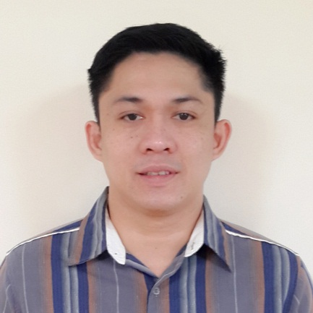
ARCHIVAL
ARCHIVAL.362648@2freemail.com

PROFILE & QUALIFICATION SUMMARY
- Self-motivated, hardworking and enthusiastic individual that can be decisive and work under pressure.
- A people oriented individual who understands the importance of TEAM WORK and CUSTOMER SERVICE, having the ability to communicate and work with different individuals.
- Fast learner who’s willing to undergo training in minimum supervision with patience and determination.

WORK EXPERIENCE

Omniyat Al Mustaqbal General Trading LLC. (March 2015 – December 2016)
Al Bayat Center Burdubai Dubai UAE

Position:
Preparing Team Leader-Logistic Department
Job Description:
- Managing the preparing team
- Making daily prepared item report
- Checking and printing invoices of the customer
- Getting the item from the warehouse
- Preparing the right item for the customer

BDS Accounting Services (May 30, 2012 – January 30, 2015)
Bustos Bulacan, Philippines

Position:
Office Staff
Job Description:
- Ensures that each client receives outstanding service satisfaction by providing a friendly environment.
- Encoding their sales and expenses receipt.
- Computing of the right amount of tax.
- Submitting and paying of taxes in authorized bank and municipal BIR branches.

Junelyns Computer Café (March 2007 – March 2011)
Bustos Bulacan, Philippines

Position:
Customer Service Assistant / Computer Technician
Job Description:
- Ensures that each customer receives outstanding customer service satisfaction by providing a friendly environment.
- Helping and guiding customers to use the computers and surfing in the internet.
- Troubleshooting of the computer hardware and software.
- Installing computer software.

SKILLS

- Possess strong analytical, interpersonal and problem solving skills.
- Good in written and verbal communication skills.
- Customer-oriented.
- Highly trustworthy, loyal, hardworking and ethical
- Resourceful in the completion of projects, effective at multi-tasking
- Detail oriented and possess self-discipline.
- Ability to work under pressure
- Flexible & adaptable, able to work individually or within a team.
- Computer literate(MS Office)

EDUCATION

2002-2006 Jose Rizal University Bachelor of Commercial Science Major in Computer Science
#80 Shaw Boulevard,
Mandaluyong City, Philippines

PERSONAL INFORMATION
Gender : Male
Citizenship : Filipino
Date of Birth : October 29, 1984
Civil Status : Married
Height : 5 ft. 9 inches

I hereby certify that all information are true and correct with all my knowledge and belief.

