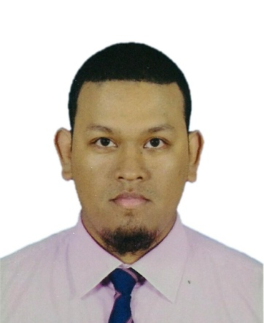
CIRRICULUM VITAE
MICHAEL
EMAIL: MICHAEL.362661@2freemail.com
OBJECTIVES:-

To obtain a position in a company where I can utilize my administrative and analytical skills and acquire new abilities.
HIGHLIGHTS AND QUALIFICATIONS:-

Positive attitude towards work, Upbeat personality, smart and responsible
Self-starter, sincere and committed person, Quick learner responsible team player, Systematic, focused, Dedicated & disciplined, Hardworking, trustworthy, performed my duties very diligently
WORK EXPIRIENCE:-

Worked as Cashier Cum Costumer Service Attendant in Magsons Supercenter in Goa, India for One year (04th January 2015 to 26th March 2016)
DUTIES ASSIGNED :-

- Sending mail, Data entry, Purchase entry of everyday sale
- Deal with companies approaching to buy and have benefits like membership, discounts, etc
- Organized money, prepared nightly deposit forms and set up store computer system for the next day
- Designed and put together store displays
- Looking after expiry product, and Frozen items
- Performed Cashier, Customer Service Attendant , bagger
- Balanced out daily sales history at the end of shift
- Supervised baggers and other cashiers and assisted customers with finding items
- Advising customers on healthier name-brand items
- Purchase person and stock receiver
- Settling invoice, credit notes, performed packaging

Worked as Room attendant in Royal Orchid Beach Resort and Spa, Galaxy in Goa, India for five months.(23rd July 2012 to 31ST December 2012).
EXPERIENCE IN HOSPITALITY :-

- Housekeeping
DUTIES ASSIGNED :-

- Attending Customer Call
- Cleaning Account Department Area, Manager office
- Cleaning Public area i.e Lobby, Restroom, Restaurant, Conferrence hall
- I have done duties from General, Afternoon shift, Night shift
ADDITIONAL COURSES :-

- Gesto Culinary And Hotel Management Course (Front Office Management Diploma) in Goa, India for One year (2012 to 2013)
- Basic Diploma in Office Assistant – Ms-Word, Ms-Excel and Ms-Powerpoint ( 2008)
- Job Training in Shrama Shakti Bhavan Panaji Goa, India for Two months and 10 days – trainee on Ms-Word, Ms-Excel and Ms-Powerpoint
EDUCATIONAL ATTAINMENT:-

- Fr. Agnel High School Pilar Goa India : 2004-2009
- Fr. Agnel Higher Secondary School Pilar Goa India (Two years course Computer Technique Vocational stream) : 2009-2011
PERSONAL DETAIL :-

Date of Birth : 04/07/1991
Nationality : Philippines
Gender : Male
Age : 25yrs old
Passport DOI : 25/05/2016
Passport DOE. : 24/05/2021
Visit visa DOI : 10/04/2017
Visit visa DOE : 10/07/2017
Hobbies : Basketball, Chess, Football, Badminton, Billiard, Carom
Languages known : English, Tagalog, Bicol

I hereby certify that above information is true and correct to my best of my knowledge and belief.

APPLICANT

