Enas

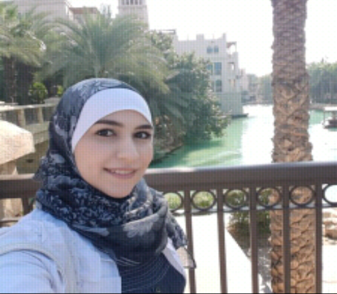
enas.362698
Personal Summary:
I am 3 years graduated pharmacist with a real passion for healthcare and the ability to develop and grow a pharmacy business. Experienced in reading administrative records such as pharmacy files / patient profiles and in providing customer care by accurately dispensing prescribed medications. Able to advise patients on medication brands, medication storage, medical equipment and health-care supplies.
I have the ability to learn quickly and I am a good team player. I am well organized and able to work under pressure.
Currently looking for a suitable pharmacist vacancy in a modern well equipped pharmacy.
Education and qualification:
Al- Noor international school 2009
High secondary degree: science section 91.3 %
Ajman University of science and technology
Bachelor of Pharmacy, June 2013
GPA: 2.47
Work Experience:
Aya Pharmacy, Sharjah, UAE, June- July 2011
Ordering and managing drugs in the pharmacy.
Entering medicines data to the computer.

Gulf Pharmaceutical industry (JULPHAR), Ras Al-Khaima, UAE, June – July 2012
Measuring, Packaging, labeling and recording medications issued to the patients.
Sheikh Khalifa Hospital, Ajman, UAE, September- December 2012
Instructing patients on how to use medications, possible side effects and storage.
Working closely with other healthcare professionals.
New Ansar Pharmacy, Ajman, UAE, February- June 2013
Accurately dispensing drugs to patients according to a doctor's prescription.
Communicating with customers sympathetically and supportively.
Sheikh Khalifa Hospital, Ajman, UAE, February- June 2013
Reading administrative records such as pharmacy files / patient profiles.
Understanding medical diagnosis, laboratory investigations and pharmaceutical diagnosis.
Providing proper counseling.
Al- fajer pharmacy, Sharjah, UAE, November 2013 – October 2015. Ordering and managing drugs, as a trainee pharmacist.
Nadia pharmacy, October 2015 – March 2016. Trainee pharmacist
MOH: My exam will be on 14th of February/ 2017.

Skills:

Excellent in Microsoft office (Word, excel, power point).
Fluent in Arabic and English, writing and reading.
Keeping up to date with developments in the pharmaceutical industry.
Able to provide quality face to face customer interaction.
Able to teach science and chemistry classes.

