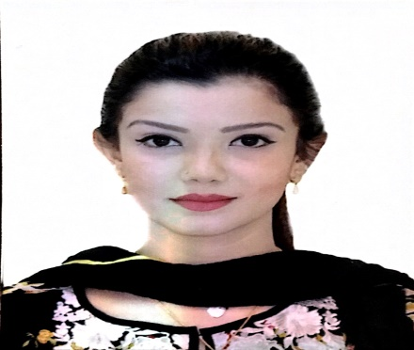
Dr. Mahreen
Email: Mahreen.362706@2freemail.com
Visa Status: Husband Visa
Address: Muweilah area, Sharjah
Nationality: Pakistan
MOH certified - Have valid MOH eligibility letter

OBJECTIVE:
To join a progressive and prestigious healthcare sector offering ample opportunities for diversified experience & enhancement of professional skills.

SUMMARY:
Having 4 years practice experience in all major departments of dentistry with skills and knowledge of multiple procedures and having worked in various institutions with large patient turnover, manage to provide complete dental care in limited resources and small setup as well as extensive OPD where competitive counselling and technical skills were key elements. Multiple workshops and conferences attended on training and knowledge enhancement and eager to learn more.

WORK EXPERIENCE:
- Madina Medical Center
Dental officer/ Demonstrator
October 2015 – July 2016
Karachi, Pakistan

- Fatima Dental Clinic
General Dental Practitioner
July 2012 – August 2015
Karachi, Pakistan

- Baqai Dental College & Hospital
Residency officer
March 2013 – April 2014
Karachi, Pakistan

CLINICAL SKILLS:
- Excellent patient management, Diagnostic & Therapeutic consultancy, Radiograph interpretation & processing
- Surgical & nonsurgical procedures, Trauma Case Management, Third molar extraction, Gingivectomy, Alveoloplasty , Suturing of intraoral wounds, Operculum management, RSI, Incision and drainage, Cyst & tumour management
- Appropriate prescription writing and Post-Operative guidance
- Prosthesis planning , Crown & Bridge design, Cantilever prosthesis design, Partial removable denture design, Complete denture fabrication, Over-Denture, Immediate dentures & Denture repair, Veneers
- Paediatric patient management, Vital & Non-vital pulp therapy, Extraction under LA, Habit breaking management & Space loss management
- Restorative & Endodontics procedures, 3rd molar RCT, Apicectomy, Cavity preparation & Filling(all types) Smile & Esthetical management , In-Office teeth bleaching
- Cosmetic dentistry procedures, Teeth whitening & polishing, Diastema closure & Smile analysis
- Orthodontic wiring, Bracketing, Bonding, Class 2/Class3 case management, Retainer design, Cephalometric analysis & treatment planning
- Outstanding case records in Endodontics, Orthodontics, Periodontics & surgery

ACADEMIC QUALIFICATION:
- Graduation
Bachelor in Dentistry - BDS
Baqai Dental College, Baqai Medical University – 2012
Karachi, Pakistan

- Intermediate
Pre Medical
PAF Degree College – 2008
Karachi, Pakistan

CERTIFICATES & VOLUNTEER EXPERIENCE:
- Participated in BASIC SURGICAL SKILLS WORKSHOP at Baqai Medical University
- Participated in Asian Congress on Dental Education at Expo Center
- Basic Life Support Program Certified
- Participated in Symposium 2012 at Baqai Dental college
- Participated in the Master Dentistry Season 1 sessions
- Participated in 1st Primary health care Conference at DOW Ojha campus
- Local School Visits For Oral health Awareness Programs
- Philanthropic work for EDHI center & Kashaan-e-Atfaal.

RESEARCH WORK:
- Retrospective study On Over Prescription of Antibiotics in General Practice
- Clinical study On Allotransplants in Dentistry

ACHIEVEMENTS:
- Awarded by SHAHEEN FOUNDATION for obtaining position in 9th Grade
- Won Poster competition at Baqai symposium on Dental health
- Chief Co-Editor in School magazine "AKS"
- Awarded 2nd position in Inter School Throw ball Championship.
- Vice-President of college magazine “Reflections”
- Awarded by Metropolitan Health club as an outstanding swimmer

COMPUTER & OTHER SKILLS:
M.S OFFICE : Word, Excel, Power Point, Outlook
Languages : English & Urdu
Freelancing : Content Writing & Editing
Fine Arts : Sketching & Painting

PERSONAL PROFILE:
Religion : Muslim
Marital Status : Married
Date of Birth : 06-06-1988

PERSONAL INTEREST:
Yoga
Swimming
Reading
Travelling

REFERENCE:
Will be furnished upon request.

