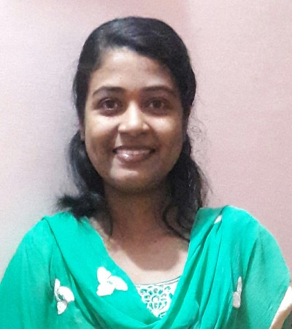

CURRICULUM VITAE

DONA
Email: DONA.362731@2freemail.com

Objective

To pursue a challenging career and to be a part of progressive organization that will give me scope to improve myself more.

Personal Details

Father name : ROY

Nationality : Indian`

Sex : Female

Marital status : Single

Date of Birth : 10/05/1990

Languages known

LANGUAGES | READ | WRITE | SPEAK
Malayalam
English
Hindi

Academic Record
COURSE | INSTITUTION | UNIVERSITY/BOARD
B Sc computer Science | K.V.V.S College, Kaithaparambu,Adoor | Kerala University(2008-2011)
Plus Two | M.K.G.A.M HSS, Mannady | State, Kerala(2006-2008)
SSLC | G.H.S, Kadampanadu | State, Kerala(2006)

Passport Details

Place of lssue: Trivandrum

Date of lssue :16/04/2014

Date of Expiry: 15/04/2024

Strengths and skills

- Hard working and willing to take on new responsibilities and responds to it with good initiative
- Ability to develop interpersonal relationship
- Self motivated,independent willing to perform multiple and cross functional tasks
- Good listened

Work Experience

- Customer Care Executive for 1year 6 months at Vertex Customer Solution pvt ltd(kaloor, kochi).
- Front office assistant at Renai Medicity Hospital, palarivattom (1year).
- Working as front office executive at RIMS Hospital,Erattupetta(1 year 7 months)

Duties
- Patient registartion
- Answering telephone calls and dealing with face to face enquiries
- Greeted all patients and visitors in a pleasant manner
- Maintained a record of all payments and credits on the billing system
- Scheduling appointments for patients
- Maintaining a clean reception area to show a professional image
- Call-Backs
- Analyze health insurance benefits and verify insurance eligibility.

DECLARATION

I hereby declare that all the information furnished here in are true and correct to the best of my knowledge and belief.

Place : Kadampanadu

Date : Dona

