CURRICULUM VITAE
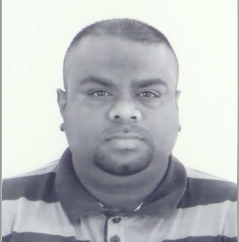
Pregason
Pregason.362741@2freemail.com
Applied For : Payroll-H/R - Debtors
Objective:
I`m seeking a challenging position within a reputable organization offering growth where
I can use my abilities and strengths to not only grow the company but myself to.
I am a self-motivated, independent worker who can also be a team player and leader. I am computer literate and have other skills that I have to offer.

Education
- Nilgiri Secondary 1996
- Matriculated Gr12
Tertiary Education
- Excel School Of Security
- Grade B
Training Force
- Fire Fighting and First Aid Level 1

Work Expirience
Game Stores Ptn
- Handyman( Temp)

Sebcom/I-Talk Cellular
- Call Centre Agent
- Store Manager
- Debtors

The Workforce Group PTY LTD
- Assistant Debtors Manager
- Payroll Manager/Admin Manger/Hr
- Systems Co-Ordinator
- Compliance Manager
(1)
Personal Information
- Pregason Known As Shaun
- Male
- Excellent Health
- Married
- Drivers Licence Code 08 (Emirati) with own transport
- South African
- D-O-B 26/09/1978

Passport Details
- Issued In South Africa
- Date Of Issue 01/09/2015
- Exp. Date 31/08/2025
- Residence Visa (Wife Sponsorship-ADEC)

Residence
- Apartment 1214
- Arc Tower B, Al Reem Island
- Abu Dhabi
- UAE

(2

