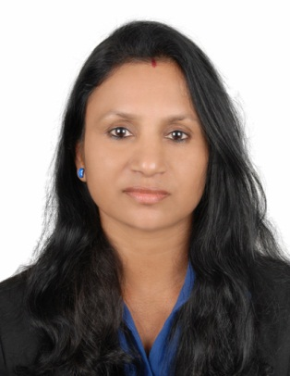 | GEETHA  Geetha.362754@2freemail.com
CAREER OBJECTIVE
To pursue a career in an organization, where my knowledge and skills contribute to its growth, and to take it to a success through my sincerity, devotion and hardwork.

KEY STRENGTHS
Communication, problem solving, planning and organization, team player.

WORK EXPERIENCE
HR / Admin. (Assistant) with M/s. Mathew International and their Allied Groups, India ( Mumbai) From March 2010 to September 2016

Roles and Responsibilities
- Assisting HR / Admin. Manager
- Drafting general, routine and confidential letters
- Handling confidential correspondence and reports on various matters
- Send and receive E-mails, Surfing Internet
- Prepare Advertisements for the recruitment
- Maintain candidates data base
- Scrutinise and shortlist the applications received
- Send interview call letters/mails as required
- Co-ordinating with candidates as well as with Clients
- Preparing for Recruitments, Status reports and related work towards Overseas deployment of candidates
- Prepare Invoices, Statement and accounts related items thereof like reminders on payments, pending issues etc.
- Personal filing of all executives.
- Co-ordinating for maintenance of office equipments.

Accounts Assistant cum Arbitrager/Dealer for M/s. Puneet Capital Services Ltd. India (Mumbai) From February 2001 to May 2008

Roles and Responsibilities
- Handling all back office work
- Attending Clients phones & co-ordinating with them
- Informing the clients about market status by phone
- After trading taking back-ups from FTP, both BSE & NSE
- Importing trade files through software (Share packages NISE LD54 & PMS)
- Preparing bills of clients
- Follow up for the payment
- Prepare Arbitragers report everyday
- Inform the Arbitragers about their everyday sheet performances
- Prepare monthly reports of the arbitragers
- Maintain stock records
- Handling Pay-in Pay-out
- Preparing cheques etc.

EDUCATIONAL QUALIFICATION
- B.A (History) from Calicut University, Kerala

COMPUTER PROFICIENCY & OTHER SKILLS
- Passed Kerala Govt. Technical Exam (lower 60 wpm)
- Passed NCFM (Dealers Module)
- Good Working knowledge in MS-Office, Word, Excel, Outlook,
- Internet Proficiency
- Excellent typing skills
- Fast learning ability
- Good communication and negotiation skills.

I do here by declare that all the above-furnished details are true to the best of my knowledge & belief.

------------------------------------------------------------------***-------------------------------------------------------------------------

