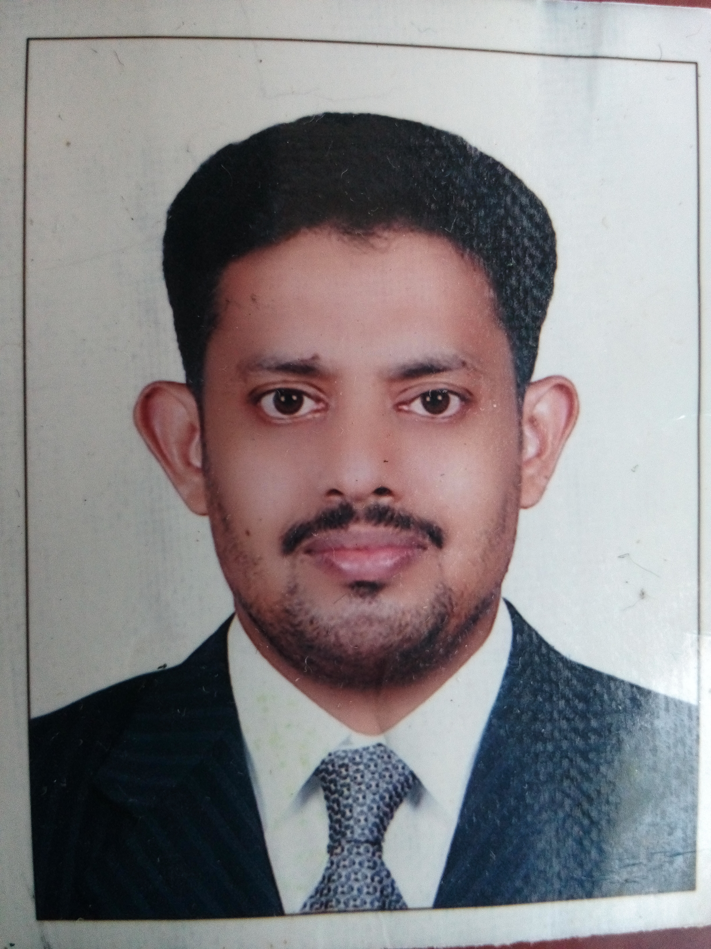
ABDU

MATHEMATICS TEACHER
E-mail: abdu.362759@2freemail.com

Personal Summary
An experienced, enthusiastic and focused teacher who is committed to safeguarding and promoting the education and well-being of children and young people at all times. I am confident, creative and highly qualified professional with 7 years of experience in the area of teaching in secondary level in UAE with approval from Ministry of Education and 3+ years in India . The profile background encompasses outstanding work ethics and obligation to organizational objectives within a highly competitive and rapidly changing globe.
Career History
Deans International School Ajman (American curriculum)
Al Ameer English School Ajman from 2011 to 2016 (CBSE India)
The New Indian School UAQ 2009 to 2011 (CBSE India)
Responsible for assisting in the educational and social development of pupils under the direction and guidance of the head teacher. In charge organizing classes and responding to the strengths and needs of students during lessons.
Duties:
• Class teacher and subject teacher of Mathematics from grade 4 to 10
• Coordinator of Maths club and Maths activities in my Al Ameer school
• Worked as the HOD of Mathematics in New Indian SchoolUAQ
• Teaching across a wide range of courses reflecting the schools curriculum.
• Developing professional relationships with pupils and staff.
• Organising and participating in all relevant subject related visits and field trips.
• Engaging students fully in their subject and keeping them focused on what they are being taught.
• Updating administrative records of each pupils progress.

Key Skills
- Good teaching, communication and motivational skills.
- Proficiency in PC operating systems.
- Proficiency in MS Office (Word, Excel, Outlook, PowerPoint) applications (Win 98, 2000, XP, Vista, Windows version 10).
- Ability to learn quickly and to withstand work pressure with ease and efficiency
- Astute leader with ability to motivate teams in surpassing their performance standards.
- A go-getter and an individual with an attitude which will adapt to any kind of situation very easily
- Proactive, resourceful, self motivated and can perform task.
- Good inter-personal relations, excellent in verbal and written communication.

Areas Of Expertise
- Badminton, Cricket and Foot ball player
- Represented Kerala state Mappila fest in Duff muttu
- Performed Kolkkali and Oppana in all India radio (Akashavani Kozhikode)
- Participated in national seminar held at SN Training college Nedungand in the topic innovative method of teaching

Academic Qualifications
Calicut University B.Sc Mathematics
Kerala University B.Ed Mathematics
Secondary Board VHSE
Board 10th
Personal Details
Date of Birth :19 – 01 – 1981
Nationality :Indian
Gender :Male
Marital Status :Married
Languages Known :English, Hindi, Arabic, Malayalam

Declaration
I hereby declare that all the details submitted above are true to the best of my knowledge
and any action may be taken if found fault with.

