Sai
SAI.362765@2freemail.com

GLOBAL CUSTOMERACQUISITIONS &SALESOPERATIONS MANAGER

Tofurthermyprofessionalcareerwithanexecutivelevelmanagementpositioninaworld classcompany. Seektodiversify myskillsinanotherindustryandaspartofa largerorganization.Ideally,IwishtohaveafocusinmarketingforagrowingorganizationpreferablydealinginTourism, RealEstateand/orBusinessacquisitions.

WORKEXPERIENCE
TECHNICALSKILLS

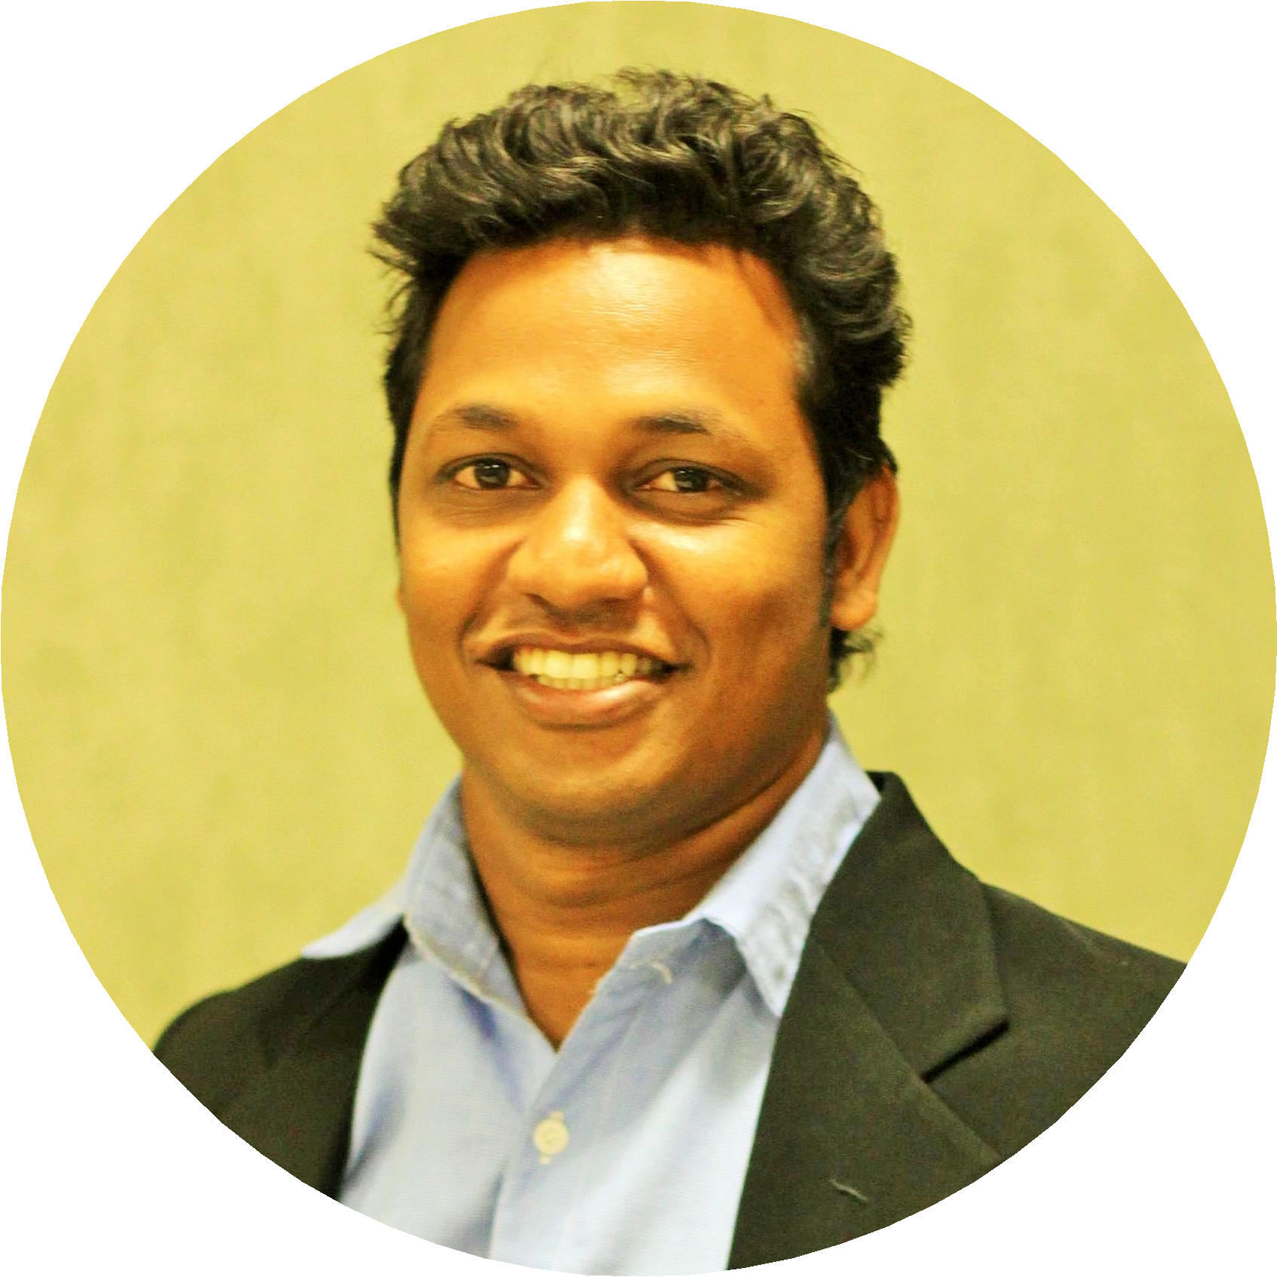LUCEPTECHNOLOGIESPVTLTD
GLOBALCUST ACQUISTIONS&SALESOPERATIONSMANAGER(Apr2016 toPresent)11Months

•Acquired1000+ companiesinspanof6monthsacceleratingtheirsalesgrowth.
•Analyzeandimprovemarketing,salesandoperationalperformance. HandlingTeam ofTele-marketers.
•TrainingNewJoiners. HeadingEvents, Conferences&PromotingwithLikelyInvestors.
•Developproducts,marketsandrelationships,meetinggoals &abilitytofollowthrough.

DishaResorts-Tours&Expeditions
BusinessDevelopmentManager(Sep2015 toMar2016) 6Months

•Assistingclientsinmakingtravelarrangementforbothbusinessandholidaypurposes.
•Providequotestofindthe bestvalue optionsavailableand makebookingsfortransport,accommodation, sightseeingactivitiesandothertravelrelatedactivitiesaclient mayneed.
•Customer&BusinessAcquisition.CorporaterelationshipManagement.
•AccomplishedBrandmarketingaslocalhubspotforweekendsthroughDigital, Ads&Print Media.

Hewlett-PackardEnterprise (HP)
Team Lead&Senior TechnicalEngineer (Jun2010 toAug2015) 5Years&2Months

•Leadateamof20technicalengineers onhighendHPthin clients.
•Providingtrainingtothe newhires&nurturethemfortillgolivefor3months.
•Resolvecustomer escalations&Visitingnew installationonsite.

Hewlett-PackardGlobalsoftIndia Ltd(HP)
CustomerRelationshipManagementSpecialist(Oct2006 toMay2010) 3Years&7Months

•ManagingCustomerescalationonthe Desktop&Laptops.
•Up-selling&revenuegeneration.
•Headedemployeeengagementcommittee,Awardee ofnumerousService recognition.

VanguardInfosolutions
CustomerSupport Executive(Jan2004 toJun2006) 2Years&5Months

•Tele-caller -OutboundSales.
•Outboundmarketing&selling UKmobileproducts.
•Wasalso anIndependent AdviseronswitchingGas&electricityinUK.

EDUCATION Dr.C.V.RamanUniversity
BachelorsofCommerce

Udemy
LeanSixSigma WhiteBelt

LinkedIn
AgileProjectManager(2016-2017)

FEATUREDPROJECTS

CustomerEngagement(HP)VOWSurveys
-Proactivelyfollowupleadsgeneratedfromcanvassingbythe accountmanagers.Maintain-superior relationships withallbusinessclients.

Meet PeopleSocializingFamily Travelling Holidays WebSurfing
CustomerRelations
Advertising
SocialMedia MarketingStrategyDevelopment EmailMarketing
Sales CallsBusinessPlans LeadGeneration Sales ManagementMarket Research Data Analysis

PERSONALSKILLS

Devoted

GoalOriented Innovative Initiator Adaptable

LANGUAGES

English(UK)
Professional WorkingProficiency

Hindi
Professional WorkingProficiency

Tamil(Indian)
NativeorBilingualProficiency

PERSONAL

Nationality
India

DateofBirth
1982/04/13

MaritalStatus
Engaged

Driving License
Yes

VOLUNTEER

-Organized HealthCamps.
-BloodDonor (Regular).
-Step involunteerforanysocialWelfare.

