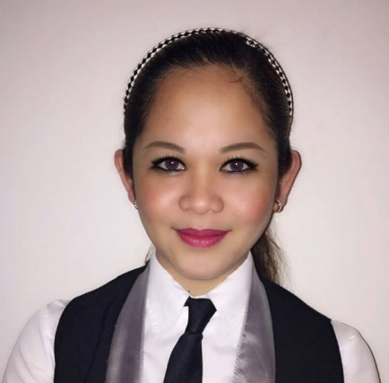
SYRELL
SYRELL.362817@2freemail.com ______________________________________________________
Objectives:
To obtain a position that will enable me to use my strong
Organizational skill, educational background, and ability to work well with people.
______________________________________________________________________________
SPECIAL SKILLS:
Proficient in oral and written communication, food and beverage service, computer literate and front office operation, cashiering, handling catering services.

WORK EXPERIENCE:

Slices Catering Services
Green Field Community School, Dubai UAE
Sept 20 2015 to Feb 22 2017
(Cashier/kiosk in charge)
(School base)

Duties Responsibilities
- Greet customer as they arrive in the store and provide them with information
regarding products/or services.
- Receive payment by cash,check,credit card,vouches,or authomatic debits.
- Issue receipts,refunds,credits,or change due to customer.
- Count money in cash drawers at the beginning of shifts to ensure that
amounts are correct and that there is adequate change.
- Respond to customer complaints and take necessary action resolve their
issue.

RAWABINA RESTAURANT & SWEETS
Al Gharhoud, Dubai, U.A.E
April 15, 2013 to July 31, 2015
(Hostess, Receptionist / Waitress)

Duties Responsibilities
- Welcoming guest
- Demonstrating menu knowledge
- Up selling specially items
- Describing dishes
- Taking orders(food and beverages)
- Handling complaints
- Ensuring guest satisfaction

PICASSO BOUTIQUE SERVICED RESIDENCES
Makati City Philippines
April – December 2012
(Office Receptionist)
Makati City Philippines

Duties Responsibilities
- Answer telephone, & direct calls
- Take and relay messages
- Provide information to callers
- Greet persons entering organization
- Deal queries from the public and customers.
- Direct persons to correct destination.
- Ensure knowledge of staff movement in and out of organization.
- Monitor visitors access and maintain Security awareness.
- Organization conference and meeting room bookings.
- Co-ordinate meeting and organize catering.
- Monitors and maintain office equipment.

NOVO MERCHANDISE & ENTERPRISES
June 15,2010-June 1,2011
(Sales Clerk)
Catarman Northern Samar Philippines

Duties Responsibilities
- Greet and talk to customer in courteous manner.
- Handle inbounds calls from customers.
- Answer and respond to customer inquiries regarding merchandise.
- Assist customer in locating the merchandise they need.
- Display merchandise on lacks in attractive manner.
- Prepare list of item to be re-stocked.
- Assist customers in completing the purchases.
- Handle refunds, returns and exchange of merchandise.
- Follow check list after opining and before closing the shop.

SUR BEACH RESORT BORACAY
(Bar station & Dining area)
Station 1, Balabag, Boracay, Island
Malay, Aklan, Philippines
May 16-30, 2011

BORACAY PENINSULA RESORT
(Dining and Receptionist Cashier)
Station 2, Balabag, Boracay Island
Malay, Aklan, Philippines
April 3 – May 13, 2011

LA CARMELA DE BORACAY RESORT HOTEL
(Fine Dining Restaurant)
Beachfront, Station 2, Balabag, Island
Malay, Aklan, Philippines
June 3-20, 2011
SEMINARS/TRAININGS ATTENDED:

NATIONAL CERTIFICATE 11 in Housekeeping
Issued by TESDA on March 28,
2011UEP Hostel,University of Eastern Philippines
University Town, Catarman, N. Samar
“Student Intellectual Enhancement Seminar”UEP-Gym- University of Eastern Philippines

“BATTLE OF THE CHEFS FESTIVAL 2010”
UEP Hostel, University of Eastern Philippines
University Town, Catarman, N. Samar

CERTIFICATE OF PARTICIPATION”
Chef’s on Parade on February 15, 2010
UEP-Gymnatorium
University Town, Catarman N. Samar

PERSONAL INFORMATION:

Sex : Female
Age : 25 years old
Date of Birth : November 21, 1991
Civil Status : Single
Citizenship : Filipino
Religion : Catholic Christian

EDUCATIONAL BACKGROUND:

COLLEGE EDUCATION : BACHELOR OF SCIENCE IN HOTEL AND RESTAURANT MANAGEMENT
UNIVERSITY OF EASTERN PHILIPPINES
CATARMAN N. SAMAR
S.Y: 2008-2012

SECONDARY : FAIR GEMS ACADEMY
CATUBIG NORTHERN SAMAR
S.Y: 2004-2008

ELEMENTARY : CATUBIG CENTRAL ELEMENTARY SCHOOL
CATUBIG, NORTHERN SAMAR
S.Y: 1998-2004
I declare that these Personal Data Sheets has been accomplished by me and is true, corrected and completed statement to the provisions of pertinent laws, rules and regulations.

Applicant

