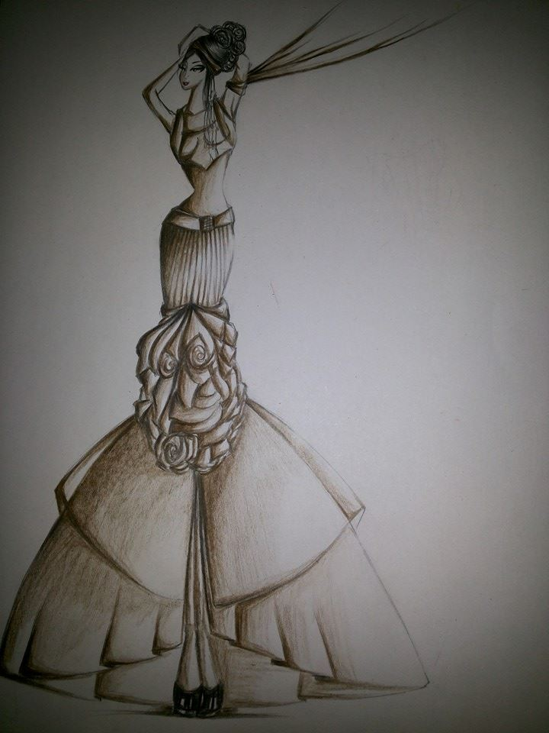
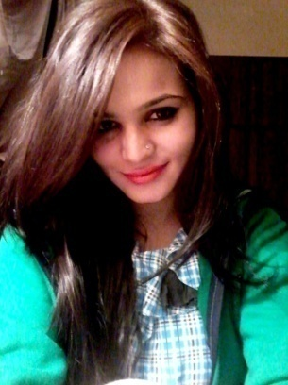
SYEDA

Syeda.362837@2freemail.com

OBJECTIVE:

To be given the opportunity to launch a better and more responsible position, in a prestigious organization in order to play an essential team member role and where my skills can be utilized towards the growth and development of the organization, thereby enhancing company and my career progress for mutual benefit.

WORK SUMMERY:

- Worked as a freelance “Sketch Artist” with Unilever
- Working as a “Thesis Supervisor” in Indus University. (Courses details : Collection-2 (Thesis) & Dissertation)
- Working as a “Fashion Coordinator” in Karachi School of Arts. (Courses details: Fashion Illustrations, Portfolio Development, Collection (Thesis), Draping and Drawing & Design)
- Conducted a Summer Workshop 2014 at Karachi School of Arts.
- Worked with the “Black & White Couture” as a Fashion Designer.
- Fashion Teacher at Institute of Business & Technology (Biztek). (Courses : Fashion Illustrations, Jewelry making & Accessory Design, Draping, Basic Drawing, Introduction to Fashion & Elements of Design)
- Freelance Fashion Illustrator. (April/2012 to present)
- Voice over artist at Radioactive 96 fm (April/2012 to May/2012)
- Volunteer work at many fashion shows: “Karachi Fashion Week” and “Bridal Couture Week”.
- Volunteer work at back stage in the inauguration of Style 360 and worked with different designers including Nomi Ansari, Hsy, Rizwan Baig and the stylist Ather shahzad.
- Worked as an usher in a fashion show organized by Veet
- Used to examine the garments on model to get better and desired results.

EDUCATIONAL BACKGROUND:

Bachelors In Fashion Design:
- Asian Institute of Fashion Design, Iqra University, Metro Tower, Teen Talwar, Main Clifton Road, Karachi, Pakistan.

Higher Secondary Certificate (INTERMEDIATE):
- Board of Higher Secondary Education, Karachi (Bahria Foundation College, Gulshan-e-Iqbal, Karachi)
Secondary School Certificate:
- Board of Secondary Education, Karachi. (Niazi Memorial Grammar School, North Nazimabad, Karachi)
COMMUNICATION:

Good communication skills gained from presentations in front of large audiences consisting of both teachers and students

COMPUTER SKILLS:

- Practical experience with: Microsoft Word, Microsoft PowerPoint, Adobe Photoshop CS, Adobe Illustrator, Internet and E-mail.
- Good typing skills.

LINGUISTIC SKILLS:

Good written and spoken English and Urdu.

OTHER:

- Excellent at Fashion illustrations, Sketching and have good color sense.
- Keep updated to the latest trends and ideas.
- Ability to take inspirations and give various ideas regarding to garment designing.
- Ability to design outfits according to the theme and work as a fashion stylist.
- Ability to complete tasks within limited time period and handle multiple tasks simultaneously.
- Able to do any other duties related to art and fashion designing.

HOBBIES:
- Listening to songs
- Surfing internet
References will be available on request

