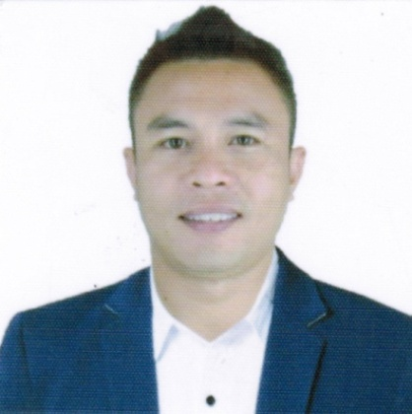
ERIC
ERIC.362842@2freemail.com

OBJECTIVE:
To be part of your globally competitive, goal-oriented work force, share skills, and contribute knowledge to the company. Portray the best image of professionalism incorporating your company’s code of ethics which define the highest level of excellence, ethical and professional conduct.

EDUCATIONAL BACKGROUND:

Pangasinan State University
Magsaysay Street, Bayambang, Pangasinan 2421
Bachelor of Secondary Education
Major in Physical Education, Health, Music and Arts.
2000 – 2002

WORKING EXPERIENCES:

NCO Philippines Clark, Inc.
Business Center 4 & 5, PhilExcel Business Park
M.A. Roxas Highway, Clark Special Economic Zone
Pampanga, Philippines

TELESALES
September ’08 – July ’09

SENIOR REPRESENTATIVE
July ’09 – December ‘09

TEAM MANAGER
December 2009 - June 2010

AEGIS PEOPLE SUPPORT
SM Fiesta Strip Harrison Rd.
Baguio City 2600

SALES ACCOUNT EXECUTIVE
December 2010 – June 2011

REAL TIME ANALYST /ADMIN
June 2011 – July 2012

CONVERGYS PHILIPPINES
Building A Ayala Techno Hub
Camp John Hay Loakan Road
Baguio City 2600 Philippines

CUSTOMER SERVICE ASSOCIATE II
August 2016 – January 2017

SKILLS:
- Excellent Communication
- Computer Navigation expertise
- Multi-Tasking
- Work Under Minimal Supervision
- MS Office Tools Expertise

PERSONAL DATA:
Birth date : March 03, 1983
Birth place : Pampanga
Age : 34
Marital Status : Married

I testify that details stated herewith are true and correct.

Sincerely,

