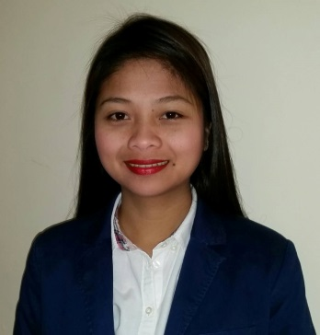
SHEENA
Sheena.362843@2freemail.com

OBJECTIVE

Seeking a varied role that will allow me to consolidate both my education and professional background, expand my knowledge and provide opportunities for personal and professional growth.

PERSONAL INFORMATION

Date of Birth: September 13, 1991

Age: 25 yrs. Old

Civil Status: Single

Religion: Roman Catholic

Language Spoken: Filipino and English

EDUCATIONAL ATTAINMENT

College: BACHELOR OF SCIENCE IN COMPUTER SCIENCE
Don Mariano Marcos Memorial State University – SLUC
S.Y: May 2008 - March 2012

Secondary: SAINT MARY OF THE SEA ACADEMY
Poblacion, Sto. Tomas, La Union
S.Y: June 2004 – March 2008

Primary: STO. TOMAS CENTRAL SCHOOL
Poblacion, Sto. Tomas, La Union
S.Y: June 1998 – March 2004
TRAININGS AND SEMINARS ATTENDED

- Job Placement Seminar-Workshop
DMMMSU-SLUC Agoo, La Union
November 28-29, 2011

- On-the-Job Training
Philippine Overseas Employment Administration (POEA)
San Fernando City La Union
April 11 – May 23, 2011

- Presentation Skills in IT (Microsoft Visual Basic 6.0)
With the Theme: “Developing Potentials for Future Credentials”
March 8, 2011

- Advance Introductory Lessons to Visual Basic Programming 6.0
With the Theme: “Developing Potentials for Future Credentials”
March 1, 2011

WORK EXPERIENCES

- Office Assistant
Al Hosn University
Admission and Registration Office
Old Airport Rd., Abu Dhabi, U.A.E
March 1, 2015 – Present

Duties and Responsibilities:

- Preparing students ID cards and scanning photos for the system
- Maintaining the accuracy of files according to their file number
- Filing all the documents of the students request, original papers and lettes.
- Encoding transaction number of each student who requested for the transcripts and graduation letters (Arabic and English).
- Assisting students to filling the online survey for the graduate students.
- Checking names of the graduated students for preparing the certificates.
- Stamping and Sealing documents from the university and prepare before the students come to take it.
- Sending important documents to the other department of the university.
- Assisting the staff for their needs (photocopying and taking files).
- Calling the students to inform them about their request and any other information coming from the admission and registration.
- Personal assistant for some cases.

- Housekeeping/Cleaner
Abu Dhabi Municipality
Salam St., Abu Dhabi, U.A.E
March 1, 2013 – February 26, 2015

Duties and Responsibilities:

- Maintaining the high-standard cleanliness of the given area.
- Use and operate hygiene’s materials.
- Polishing and dusting walls, glasses, doors and any other displays on the location given.
- Maintaining dry and clean with pleasant ambiance of the toilets.

- Expanded – Government Internship Program (E-GIP)
Department of Social Welfare and Development
Field Office 1
City of San Fernando, La Union
May 20 – July 21, 2012

Duties and Responsibilities:

- Surveying the population of the given place.
- Interviewing one of the family members regarding their livelihood.
- Counting the senior citizen and malnourished children of the family.
- Distributing the lists of the PhilHealth insurance.

ACHIEVEMENT

CERTIFICATE OF APPRECIATION
Cleaning Training and Demonstration
Abu Dhabi Municipality, Abu Dhabi, United Arab Emirates
December 31, 2013

WORK SKILLS AND SPECIAL ABILITIES

- Can type fairly and knowledgeable in Microsoft Office such as Microsoft Word, Microsoft PowerPoint and Microsoft Excel
- Dedicated in work given at hand
- Can handle any given task covering human relations
- Can work with under pressure

