Objective:
RESUME
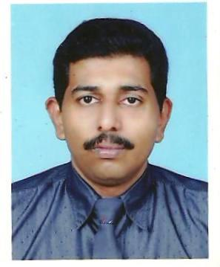
George.362846@2freemail.com

Experience:
19 years, (UAE)

▪ Design ▪ Tendering & Estimation
▪ Execution

Approvals:
Dubai Municipality, SEWA & FEWA Approved Engineer
Qualification:
▪ Bachelor Of Engineering (B.E) in Electrical & Electronics from Mangalore University, India.
Desired Position:
Sr.Projects Manager

Seeking a suitable working platform in the area of project management, consulting or contracting highlighting design, tendering, execution and coordination with a company that will provide opportunities to polish the acquired skills and foresee new trends for effective advancement.

Working Experience: Feb’ 2016 – Till date
Company : AE Arma Electropanc Electromechanical works LLC
Project : Bluewater Wharf Retail Project
(Demarcated retail, residential, hospitality and entertainment zones )
Client : Meraas / Mirage Developement
Consultant: WSP Middle East Ltd
Main Cont.: ALEC
Position : MEP Project Manager - Retails
MEP Value : 227 Million AED
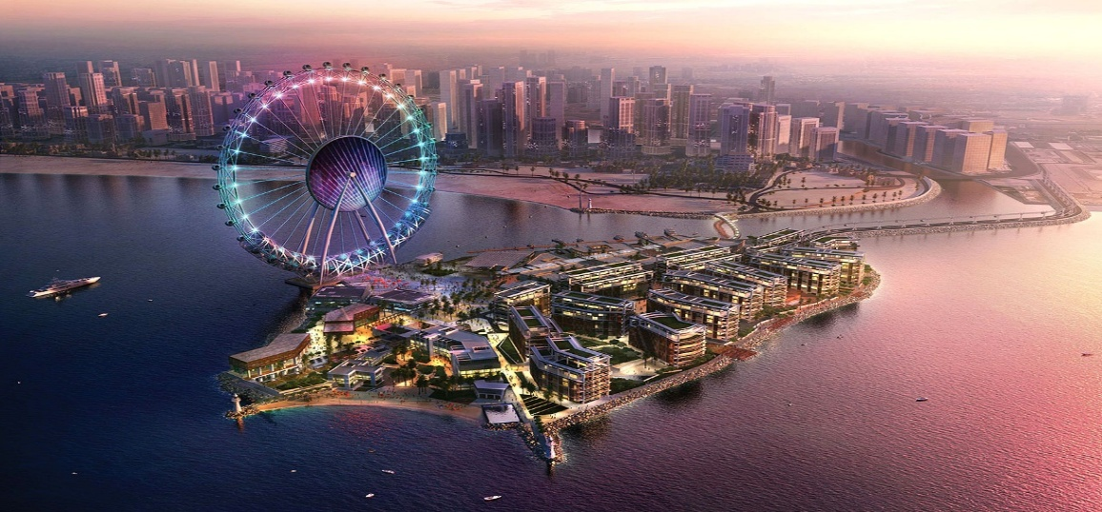

Nature of duties and Responsibilities
- To ensure timely completion of project within approved budgets on cost, resources without compromising on Quality & Safety.
- Responsible for planning and scheduling of all major activities of the Project to achieve timely completion of the Project.
- Coordinate with the design team on all aspects of the design.
- Ensure all technical aspects of the projects are strictly complied and in conformity with Conditions of Contract, Particular Specifications, General Specifications, Contract Drawings & BOQ.
- Attending regular meetings ( on work progress, coordination, design, etc. ) with Main Contractor and Consultant to discuss key issues related to the project and take effective corrective actions
- Develop Action and Recovery plans to support program delivery on time.
- Oversees activities of Construction Manager, Project Engineers, and Site Superintendents on assigned projects.
- Establish, update, and communicate Master Project Schedule and manage its implementation
- Prepare periodic reports for management including status of budgets, variance/change claims, schedules, disputes, up-coming activities & safety records.
- Identifies risks to project and corporation and works with Project Executives and Director of Operations to mitigate risks.
- Assisting the Senior Project Manager in setting up, adjusting and improving the plans, procedures methods and techniques for applying the project management procedures to attain maximum output.
- Monitoring the progress of the shop drawings and materials submittals with reference to the approved planning schedules and monitoring work progress on site accordingly
- Monitoring and follow up the approval of Interim Payment Certificates (IPC) with Main Contractor.
Working Experience: March’ 2015 – Feb 2016

Company : AE Arma Electropanc Electromechanical works LLC

Personal Data

Date of Birth:

May 22, 1974

Gender:

Male

Nationality:

Indian

Marital Status:

Married

With:

Valid UAE Driving License

Visa Status:
Residence Visa(2 years)

Languages known:
English, Spoken Arabic, Hindi

Other Qualifications:

MS-Office 2007, Autocad 2007

Undergoing MBA in Projects Management
Project : University of Dubai, Academic City , Dubai
(University centre,College of Business, College of IT)
Client : Dubai Chamber of Commerce
Consultant : Dar Al Handasah
Main Cont. : Kier Dubai LLC
Position : Project Manager
MEP Value : 31 Million AED
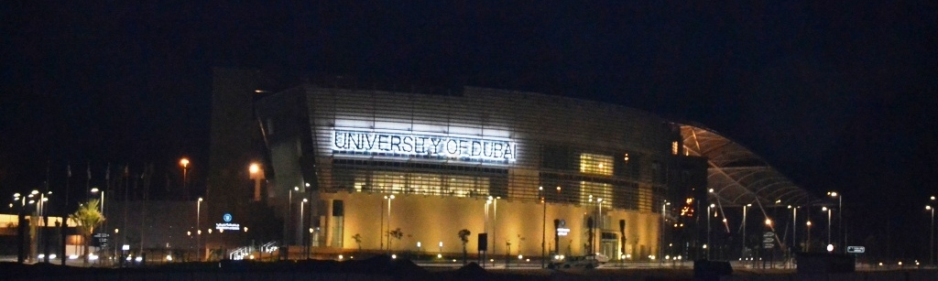

Nature of duties and Responsibilities
- Responsible for planning and scheduling of all major activities of the Project to achieve timely completion of the Project.
- Determine all Project requirements (Technical and General).
- Establish work plan and staffing for each phase of project, and arrange for assignment of project personnel.
- Responsible for overall quality and management.
- Monitoring and follow up the approval of Interim Payment Certificates (IPC).
- Plan, direct, coordinate, and lead the project to ensure that goals, objectives and quality of the project are accomplished within the prescribed time frame and funding parameters.
- Determine all Project requirements (Technical and General).
- Define and clarify project scope, develop project plan, schedule, policies and procedures to support the achievement of the project objectives
- Determine the organizational structure of the project team
- Identify services to be provided by external companies
- Setting team direction
- Checking project progress toward meeting its objectives, determining the cause of deviations from the plan & taking corrective actions to address deviations
- Review status reports prepared by project personnel and modify schedules or plans as required
- Assisting the project director in setting up, adjusting and improving the plans, procedures methods and techniques for applying the project management procedures in the most proper output..
- Monitoring the work progress on site and the progress of the shop drawings and materials submittals with reference to the approved planning schedules.
- Preparing and managing the contracts, B.O.Q and all the contractual documents for bidding process of the different trade contracts

Working Experience: Feb’ 2011 – Feb-2015 (4 years )

Personal Data

Company : Al Sapphire Electromechanical works , Dubai
Al Sapphire Electrical & Mechanical Contracting
LLC, Sharjah

Position : Electrical Department Manager / Project Manager

Nature of duties and Responsibilities
- Electrical design of medium commercial and residential buildings,logistic facilities, warehouses ,luxury villas,midrange factories and obtain approval from Engineer, DEWA & SEWA
- Design of Nestle Middle East ,B+G+1 Office Bldng, Jebel Ali.
- Design of Grand Stores ,Logistic Facility, DIP , Dubai
- Design of Gulf Rope Factory ,Sharjah Cements,Sharjah
- Design of Primary & Senior Block extensions, Delhi Private School, Sharjah.
- Design of G+M+2 Building for Sharjah Cements Co, Sharjah
Ongoing and completed projects from Feb 2011 -2015
- G+M+4 Bldng & 08 Villas – Design Centre Consultants,Dubai
- Gulf Rope Factory LLC- Sharjah Cements,Oasis Engg.Conslt. Sharjah c). G+M+3 Office Building for Anwar Badri,B&A Consultants, Naif, Dubai.
- G+2 Victory Heights Primary School, Sports City, Saray Consultants
- G+1 Luxury villa for H.E. Saeed Ahmed Ghobash,B&A,khawaneej,DXB
- G+1 Primary Block for Delhi Private School, Oasis Engg Consultant, Sharjah
- G+2 Senior Block for Delhi Private School, Oasis Engg Consultant,
- Sharjah, Office for Badri & Associates, Diamond park, Dubai.
- Office for Syna Engg Consultants, Prism Tower, Dubai.
- Extension of Ramee Rose Hotels, NEB, Barsha, Dubai.
- Showroom for B5- Art of Living, Sidra Towers,B&A, Dubai
- G+1 Luxury villa for Sharjah Cements, Oasis Engg , Sharjah

Working Experience: May’ 2007 –Feb’ 2011 (3 years & 9 months)
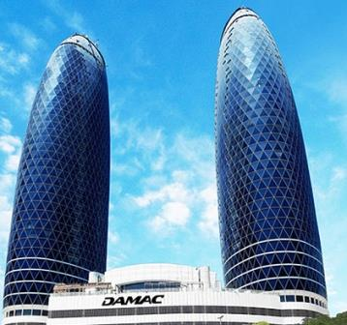
Company : Omega Engineering LLC, Dubai, U. A. E.
Project : Park Towers(3B+7P0d+42Floors Twin Towers) DIFC,Dubai
Client : DAMAC Properties
Consultant : Engineering Consultants Group/ Ian
Banham
Main Cont. : Shapoorji Pallonji Mideast LLc
Position : Asst.Project Manager/Sr. Electrical Engineer
MEP Value : 121 Million AED

Nature of duties and Responsibilities
- Preparation material submittals , shop drawings by providing engineering inputs to drafting department,review,approve, and obtain approval from Engineer & local authorities
- Labour forecast based on construction program and allocation of labours as per exact site situation, review and monitor labor performance and utilization against planned targets.

- r.Manager,Du

eferReferonal Data

- Ordering of materials, follow up and ensure prompt delivery.
- Preparation of progress reports ,attendance of scheduled meetings with relevant parties.
- Responsible for mentoring, guiding ,coordinating with Project Engineers, Site Engineers & Supervisory staff for work allocation and execution on a daily basis.
- Responsible for planning , preparing , documenting and supervising all matters related to Testing & Commissioning and final approval from Local Authorities. .
- Responsible for handing over the project to the satisfaction of Engineer & Client.
Working Experience: March’2004 - April’ 2007 (3 years)

Company : Solico Contracting Co, Sharjah / Dubai.
Position : Senior Electrical Engineer

Nature of duties and Responsibilities
- Electrical design of medium commercial and residential buildings, approvals from consultants, DEWA & SEWA.
- Design of Marriot hotel staff accommodation, SYNA, DIP, Dubai.
- Design of Capriole contracting staff accommodation, DIP, Dubai.
- Design of 2B+G+6 Bldg of Al- Ferodouni, Barsha,Dubai.
- Design of B+G+6 Bldg of Saleh Al Baker, Barsha,Dubai.
- Tendering and estimation of projects, preparation of BOQ’s, Job cost analysis of awarded projects
- Execution of low voltage distribution and low current systems, preparation of workshop drawings, approvals from concerned authorities, approvals from consultants, coordination with all services, prompt transmittals, liaise with all authorities and subcontractors for testing & commissioning, as built documents etc.
Major Projects Completed
- 28 Villas For Syed Al-Baloushi , UmmSuqeem, Consultant:Emaar Al Khaleej,Dubai. MEP Value – 34 Million AED
- B+G+4 Building for TECOM,Dubai Media city, Consultants: DAR/Ian Banham, Dubai. MEP Value – 19 Million AED
- 2B+G+4 Real Estate Bank, DAR/ IBA,Garhoud, Dubai, Consultants: DAR/Ian Banham, Dubai . MEP Value – 20 Million AED
- G+2 Staff Accommodation for Emirates Roads Contracting, Consultant:ECG/ IBA, Muhaisnah, Dubai. MEP Value – 8 Million AED

sonal Data

- B+G+7 OFF + 26 Typical+ HC for Emirates Bank International Consultants:Edara/Khatib & Alami. MEP Value – 65 Million AED
Working Experience: May’ 98 – Feb’2004 (6 years)
Company : Al-Hamad Contracting Co/ DCE, Sharjah/Dubai
Position : Electrical Projects Engineer

Major Projects Completed
- National Paints- Office & Building,Arenco,Sharjah
- G+ 22 Storey Bldg for Essa Ahmed Al- Naeem,IBA, RAK
- 24 - Class room School for Ministry of Public works, IEC,RAK.
- G+ 14 Residential bldg for Ali Abdulla, Arenco , Sharjah.
- G+3 Bin Kamil Centre, Hisham Laham, Al-Wahda, Sharjah.
- G+4 Bldg for Abdel Lateef Fadl,Gulf Consultants, Sharjah.
- G+4 Bldg for Sultan Al- Mashwi, Grace Consultants ,Sharjah.
- G+6 Floor Offices for Sheikh Ahmed Bin Saqr Al- Qassimi, Hisham Laham Consultant, RAK.
- G+6 Floor offices for Sheikh Omer Bin Saqr Al- Qassimi, Hisham Lahaam Consultant, RAK.
- Marble Factory for Nashat Sahawneh,Gulf Consultants, Ajman.
- G+5 Bldg & 24 Warehouses for Saleh –Al- Sulaimani, Oryx Consultants, Sharjah.
- G+5 Bldg,G+4 offices,16 Warehouses for Nashat Sahawneh,Gulf Consultants, Sharjah

