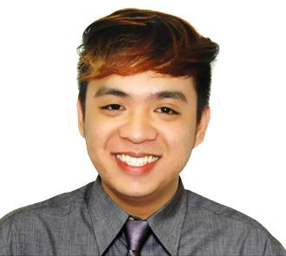
VANJO
VANJO.362864@2freemail.com

OBJECTIVE
To further my professional career with an administrative level management position in a world class company. Seek to diversify my skills in another industry and as part of a larger organization.

SKILLS
- Proactive problem solver and analytical thinker
- Proven written and verbal communication skills in English
- Demonstrated ability to work independently and as part of a team
- Excellent organizational skills
- Exceptional attention to detail with proven interpersonal skills
- Demonstrated ability to remain self motivated at all times
- Able to manage stress timely and effectively
- Flexible in working hours

EXPERIENCE
- MSWDO (Samal)
Office Staff
SPES Summer Job
April-May 2014

- Property Avenue Real Estate
Internship
November 2015-March 2016

PROFESSIONAL EXPERIENCE
- Property Avenue Real Estate
Registered Real Estate Salesperson
April 2016-March 2017

PERSONAL BACKGROUND

Sex : Male
Age : 21 years old
Civil Status : Single
Date of Birth : August 20, 1995
Place of Birth : Bataan General Hospital, City of Balanga, Bataan Philippines
Citizenship : Filipino
Language : English, Pilipino

EDUCATIONAL ATTAINMENT

Tertiary : Bataan Peninsula State University (Balanga Campus)
Balanga City, Bataan Philippines
2012-2016
Course : Bachelor of Science in Business Administration
Major in Marketing Management

Secondary : Saint Catherine of Siena Academy
Samal, Bataan Philippines
2008-2012

Primary : Calaguiman Elementary School
Calaguiman Samal, Bataan Philippines
2002-2008

I hereby certify that all information written above are true and correct to the best of my knowledge and belief.

