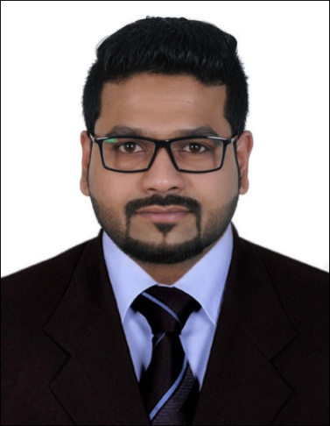
Monish
Abu Dhabi, UAE
E-mail: monish.362876@2freemail.com

Objective

To seek a challenging position in a highly motivated team, that utilizes my skills and abilities and offer professional growth while being resourceful, innovative, creative and flexible.

Current Organization

Organization : Ahalia Hospital, Hamdan, Abu Dhabi
Job Title : Insurance coordinator (Customer Relations)
Experience : Since 09-September-2015 (currently working)

Professional Experience

- Getting approvals for medical procedures

- Ensuring coverage of claims, guiding staff for correct use age of claim forms, approval papers

- Coordinating with insurance companies for obtaining information on new policies and their coverage

- Explaining coverage of medical benefits to patients when required
- Assisting invoicing department in insurance processing and billing
- To liaise with insurance companies regarding eligibility, payments, approvals, reconciliation and other requirements.
- To liaise with patients regarding their eligibility and entitlements.
- To train and educate staff in insurance matters.
- To advice the management on insurance matters.

- To design and implement a protocol for insurance practices in the hospital.
- To maintain and update records related to pre-approvals and reconciliation.
- To coordinate and co-operate with colleagues of the same department and other related departments for smooth running of Insurance operations.

- Understand type of rejection, generate justification for type correction and type internal complaint, give proper diagnosis as per the doctor medical justification, rectify clerical error.

- Prepares the complete data for reconciled amounts, outstanding due payments, collectible and receivables.

- Reviews insurance policy to determine coverage.

- Secures authorizations for all medical cases in a timely & thorough manner to maximize timely billing.

Knowledge & Skills

- Exceptional customer service skills.

- Strong communication skills.

- Able to perform multiple tasks.

- Capable to actively participate in insurance activities.

- Able to provide high level of leadership.

- Capacity to meet deadlines by working hard.

- Good knowledge of computer operations.

- Exceptional organizational skills.

- Extremely motivated and self-disciplined.

- Capable to maintain cooperative rapport with clients.

- Excellent problem solving skills.

I am greatly familiar in handling the following insurances.

- DAMAN AND DAMAN THIQA | - AL-DHAFRA
- DAMAN THIQA | - ADNIC
- NEXTCARE | - AL MADALLAH
- NAS | - AL-BUHAIRA
- AMITY | - ASCANA
- AXA | - DUBAI INSURANCE
- NEURON | - NGI
- MEDNET | - AMITY
- METLIFE ALICO | - WAPMED TPA
- OMAN | - FMC
- SAICO | - MSH INTERNATIONAL
- GLOBEMED | - PENTACARE
- INAYA TPA | - NEURON
- AL-KHAZNA

Work Experience

Organization : Infosys BPO Limited
Job Title : Customer service and support
Experience : 14 Months
Process Name : SFDC (Salesforce. com) & SCC (Sales crediting and Claiming)
Team Size : 6
Role : Process Executive

Process Description

SFDC-Salesforce.com process runs its business operations with Cisco-client under customer service and support. This process deals with creation of accounts as well as account movement to requested account manager’s and transferring opportunities linked with the account to the specific business dealer’s.

I support SCC team in our company to do the allocations related to the claims raised by our Cisco clients.

Process Description

- As an analyst we are authorized to provide SFDC sales force access to Account Manager’s & Regional sales Manger’s in order to have visibility and to review their accounts and business deals.
- As per the process accounts will be registered in SAVM tool and the same will flow in to SFDC prior to territory synchronization covering the geographic region.
- We create accounts in SFDC as per the details registered in the customer data base maintained by oracle data base management.
- As per the queries raised by RSE and RSM, we will move accounts to the requested account manager’s and the respective territory will synchronize in SFDC.
- Requester will raise queries through customer relationship management tool regarding accounts & opportunities movement to specific owners.
- We will upload opportunity reassignment template in manual reassignment tool to align deals to specific business dealers.

Education

Master of Business Administration (Marketing & H.R) - Bangalore University, India -2012
Bachelor of Business Management (H.R) – Bangalore University- 2010
+2 (PUC) - Govt.Higher Secondary School, Punalur, Kerala, India-2007
10th (S.S.LC) - Govt.Higher Secondary School, Punalur, Kerala, India-2005

Technical Expertise & skills

- MS-Office (Word, Excel, Outlook & Power Point)
- Google & other browsers
- Good research and communication skills
- Intra Organizational software’s
- Leadership Quality

Personal Information

Date of Birth : 26-12-1989,
Sex / Marital status : Male / Single,
Nationality : Indian

Languages known

To Speak : English, Malayalam, Hindi and Tamil.
To Read and Write : English, Malayalam and Hindi.

Hobbies

Playing Cricket, Football and indoor games Listening Music.

Declaration

I hereby declare that the information furnished above is true to the best of my knowledge and belief.

Place: Abu Dhabi Monish
Date:

