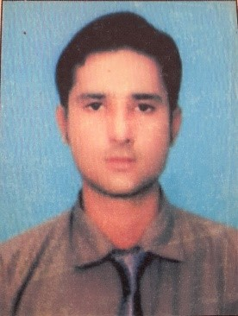
Salman
Alain, U.A.E

E-mail: salman.362878@2freemail.com

Objective:
I am looking for a career that allows me to employ my skills and creative mind, yet at the same time provide opportunities for learning and subsequent growth.

Educational Qualification:
Bachelors In Commerce | Dadabhoy Institude Of Higher Education-Karahi Pakistan in 2015

Computer Skills:
Applications | MS Office (Word, Excel, Power Point), Email & Internet Applications.  Hardware,Networking,Peachtree

Professional Experience
Assistant Supervisor . Operantion | Presently working as a Officer at EFU Life Assurance , Karachi Pakistan Since 2012 to March 2017  Responsibilities are:  - Process Fresh Business  - Documents Dispatching .  - Handing & meetings with Board of Revenue Of Pakistan.  - Clients Handling .  - Supervion Company Store .  - Maintaining Reports and Client Supporting Documents .  - Records Client Payment through Bank Statment and Cash.  - Member Of (System & Process Development Team).
Floor Team . Leader | Worked as a Team Leader at Makro Super Store – Karachi , Pakistan. for a period of 1 years from 2011 to 2012.  Responsibilities are :  - Responsible for customer communication  - Cash handling  - Making daily sales report and submitting to head office

Personal Information:
Name: | Salman
D.O.B: | 03-Oct-1993
Sex: | Male
Marital Status: | Unmarried
Nationality: | Pakistani
Languages: | Read Write Speak  English Yes Yes Yes  Urdu Yes Yes Yes
Visa Status: | Three Months Visit Visa .

I here by declare that the above mentioned information is correct up to my knowledge and I take the responsibility for the correctness of the above mentioned particulars
Salman

