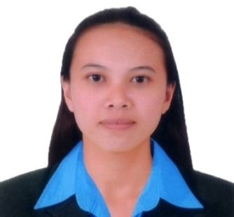
IVY
Ivy.362884@2freemail.com

__________________________________________________________________________________
OBJECTIVE:
To apply in any convenient position in your respective company to enhance my personality and capabilities, acquire valuable knowledge and skills to complement those I have learned from my previous studies in the actual job environment. I offer my service and determination to your company throughout the duration of my training.

CAREER OBJECTIVES:
To build a career in a growing organization, where I can get the opportunities to prove my abilities by accepting challenges in the field of work, fulfilling the organizational goal and climb the career ladder through continuous learning and commitment.

SKILLS:
Teaching
Oriented in Microsoft office application such as:
- Microsoft Office Word
- Microsoft Excel

WORK EXPERIENCED:

- RICKIMEL MARKETING CORP. Quezon City Philippines
Production Checker/Quality Inspector (Feb. 2014- March 2015)

Duties and Responsibilities

- To make sure that the packaging was right and in proper.
- Ensured that grams and kilos of each product are correct.
- Making list of the finished product before delivering to the store.
- Checking proper sealed, label, of the product to make it better and presentable to the consumer.

- CALTEX Gasoline Station Pili, Philippines
Cashier (August 2013- January 2014)

Duties and Responsibilities

- Receive payments from the costumer
- Always greet customer in a right manner and asses them the price which they can have more discount of.

- PATITINAN HIGH SCHOOL Sagnay, Philippines
Secondary Teacher (June 2012- July 2013)

Duties and Responsibilities

- Make lesson plan every school day, based on the subject to be taught or based on the specialization.
- Computing grades of the student based on their exams, oral tests, outputs and behaviour.
- Making report cards every grading periods and gave it to the parents for checking of their child performances.
- Attending seminars and meetings for the teaching enhancement.

SEMINARS, TRAININGS ATTENDED AND CERTIFICATIONS:

- SOUTH STAR DRUG INC. TRAINING FOR INCOMING EMPLOYEE (PA)
Naga City, Philippines (October 17-21, 2016)

- CERTIFICATION OF PASSING LICENSURE EXAMINATION FOR TEACHERS(PRC)
Legazpi City, Philippines (March 2013)

- SCHOOL CERTIFICATION FOR TEACHING (Patitinan High School)
Sagnay, Camarines Sur, Philippines (June 2012- July 2013)

EDUCATIONAL BACK BACKGROUND:

College Graduate PARTIDO STATE UNIVERSITY
Goa, Camarines Sur, Philippines A/Y 2008-2012
Course: Bachelor of Secondary Education
Major in Values Education

I hereby certify that the above information is true and correct to the best of my knowledge and belief.

