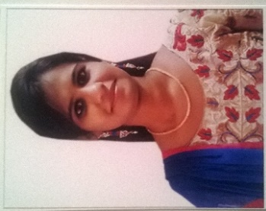
Righana
Righana.362887@2freemail.com

Career Objective:
To work in an organization where culture of freedom and working for initiatives is ensured. Aspirant in achieving the task in the highest magnitude, so as to improve myself and the company and also to be dedicated in the field.
WORK EXPERIENCE:
Human Resource Manager (HR)
- Worked in Aqua Thanish Mineral Water company - Madurai, Tamil Nadu - October 2015 to February 2017
- Had to deal with HR Support.
- Client managing of the firm.
- Had knowledge on the development of the firm.
- Helped the firm with advertising.
- Conducts recruitment showing good faith efforts to broaden diversity.
- Works to prepare the job description and ensure proper procedure for review and approval are met.
- Processes final offer and finalizes the recruitment.
- Provides consultation and assistance during the recruitment process.
- Monitors staff recruitment activity and ensures guidelines are followed for searches with the organizations.
- Ensuring employee welfare and employee relations are positive
- Ensure the working environment is safe for employees.
Technical support
- CSS corp - Chennai, Tamil Nadu - June 2015 to October 2015
- I solved all the issues relating to Cableone (telecom) email in US voice process support.
- Ensured that the email platform was changed from the old version.
- Took remote control of the customer desktop and worked with the issue.
- Helped in changing the email platform for desktop, mobile, ipad, kindle.
- I learnt customer satisfaction and relationship.
Software Proficiency:
- Capable of working in WINDOWS XP and WINDOWS 7 platforms.
Application packages:
- MS Office
- WinAVR Studio
Skill:
- Excellent verbal and personal communication skills.
- Strong analytical and people management skills.
- Ability to make sound decisions
Technical skills:
- Embedded system (AVR microcontroller).
Certification:
- Certification of training in ‘Application in Embedded System’ from Embuzz technologies private LMT, Madurai.
- Certification of ‘Software Embedded developer’ from Accel Academy, Madurai.
Projects:
- RFID based automation of tollbooth.
- Industrial automation

Educational Profile:
Course | Institution | Year of Passing | Percentage
B.E (ECE) | Sethu Institute of Technology, Kariapatti, Madurai | 2015 | 60*
HSC | Tagore Vidyalayam, Madurai | 2011 | 74.25
SSLC | Tagore vidyalayam, Madurai | 2009 | 82.4
* With backlogs

Extracurricular activities:
- Basketball player.
- District Handball player.
Strengths:
- Self-motivated, focused and dedicated
- Good managerial and interpersonal skills
- Good communication.
- Easy going and flexible to any environment
Hobbies:
- Reading books.
- Driving

