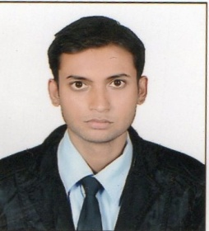 CURRICULUM-VITAE

QUAZI
QUAZI.362899@2freemail.com

OBJECTIVE:

To seek a responsible position where my work experience knowledge attitude & skills will be applied in a prestigious institution that help to achieve my personal career as well as the individual growth.

ABOUT MYSELF:-

- Outgoing person with logical thinking.
- Possesses strong oral and written communication skills.
- Positive outlook towards life and accepts challenges willingly.
- Can be an asset to the organization.
EDUCATION:-

- Bachelor of Commerce from Bamu University INDIA.
- Intermediate C.E.C from Neo Quantum Junior College INDIA.
- S.S.C- St Frances decals high school Aurangabad.
- Fire and safety training from municipal commissioner office Hyderabad
- Computer course MS Excel, MS Word , Tally ERP in 2010 From Aurangabad

Subjects | School /University Name | Passing Year | Percentage
S.S.C | St Frances school | 2006 | 52%
H.S.C | Neoquatum collage A.p Board Hyderabad | 2009 | 50%
Degree | Deogiri collage Bamu university (MH) | 2013 | 65%

EXPERIENCE SUMMARY :-

- Work as a sales manager in Alpha motors vespa showroom from nov2015 to Jan 2017
- Work as a sales executive in cherry cop Royal Enfield Bullet showroom Oct 2014 to Nov 2015
- Worked as a Sales Representative in hardwire company (Kames mashed abha Saudi Arab.)
- Work as a casher and merchandiser in mahaveer supermarket 2sep 2010 to 2013
- Work as a Supervisor in Hyderabad Carting services from aug2007 to may 2010

Personal profile:-
Sex : Male
Date of birth : 17-01-1990
Martial Status : Married
Nationality : INDIAN
Language known : English &Hindi&Marathi&Arabic

(

