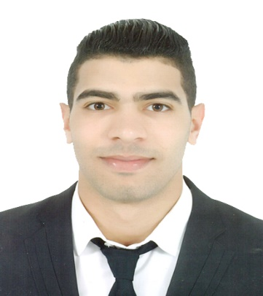  Bechir  Bechir.362912@2freemail.com  - BASIC information  *Nationality : TUNISIAN  *Date of birth : 20/01/1995  *Living in : Doha,Qatar  - Contact information  Add : Najma , blue building 1  FB : Bechir Bèjaui  - Hobbies  Camping / traveling /Skydive  /Climbing/Motorcycling  Fitness/Football/Reading/Music  - Interests  sport : I believe a healthy body is  the key to a focused mind in  Today’s hectic society.  living life: we only get one chance  in this life so I aim to get the most  Out of it . | Profile  I’m a self-motivated, committed and determined in achieving my goals.  I’m also responsible and able to relate to a wide range of people ,  and I have the capacity to work hard under pressure  Work Experience  01/01/2013 to 15/07/2013Waiter in “LATIN OOS”tea Room  08/01/2014 to 05/06/2014 Waiter in “ADEL TEA ROOM”tea Room”  11/07/2014 to 29/07/2015 fitness coach in Power.House.GYM  03/08/2015 to 31/08/2015 Internship inSociety Refining  05/09/2015 to 30/12/2015 Sales Assistant in SBB Wood Building (C)  01/04/2016 to 30/04/2016 Receptionist in“COSMOS.NET”  02/01/2016 to 10/05/2016 Waiter in “GalaxieFOOD” Restaurant  05/08/2016 to 06/11/2016 Cashier in ‘’ F.F.VIOLETTE’’ Restaurant  28/12/2016 to ‘day’ Commercial in “Qatar Airways” Company  Professional skills  -Excellent customer service - Amadeus reservation program -Microsoft Office (Word/Excel/PowerPoint) -logistic knowledge -Clear Communication Skills -Coaching -Lead and motivate and unit a team -ability to handle difficult situations -Problem solving skills -Plans and arranged activities -Openly express ideas -Negotiate -Coordinates /completes tasks -Listens attentively - Openly accept critical -can work well under pressure -Attention to details  Education&Certificate  *2009 /2013* EL CANEL (high school)  *2014 /2016* “INFO+ Bizerte” ( Diploma in Multimodal Transport)  *2016* DELFE : certificate in French language from CIEP  *2017* Certificate : Amadeus reservation program from “QA”  Language  - Arabic : Good reading/writing/communicating (excellent)  - French : Good reading/writing/communicating (excellent)  - English : Good Reading /writing/communicating (excellent)

