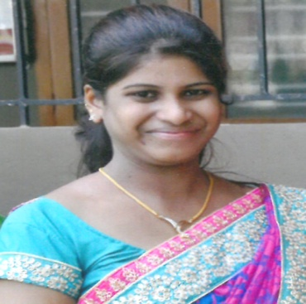
FELICIAN
FELICIAN.363010@2freemail.com

Career Objective:

To work in a challenging environment that provides ample scope for a high career growth through continues learning and to be efficient in my endeavors and prove myself worthy and to the expectations of the organization..

Key Competencies:

- The role that both students and teachers take in the learning process
- Able to Identify student needs
- Good Communication and professional relations
- Provide general administrative and clerical support

Work Experience:

Designation : Assistant Teacher
Company : St. Mary’s English Medium school, Falnir, Mangalore
(01/06/2012- 10/04/ 2016)
Holy Redeemer English Medium School, Belthangady
(18.07.2016 - 10.03.2017.)

Roles and Responsibilities:
- Instructing Students
- Special Education Teaching Assistants
- Promoting appropriate behaviour and respect for others.
- Handling all cash/chq receipts and follow up any credit payment with debtors.
- Providing learners with appropriate points of referral as required.
- Ensuring own professional development.
- Counseling and guidence

Academic Details:
SSLC and Pre University studies Mangalore
Diploma in teaching education ( D.ED)Mangalore University, India.
Bachelors of Arts (BA) Mysore University, India
PG Diploma in Counseling (PGDC) Mangalore University. India

Technical Skills:

MS Office Applications , power point, web design,.

Extra-curricular activities:

- Participated workshop on NEW HORIZONS RETREAT’,organised by ST.Ann’s convent , Mangalore, India.
- Attended the seminar on English Phonetics and Grammar, conducted by St.Ann’s High school.
- ‘English Encounters’ conducted by the teachers foundation, Mangalore, India.

Personal Details:

Date of Birth : 16 October 1990
Gender : Female
Nationality : Indian
Religion : Roman Catholic
Marital Status : Single
Languages known : English, Hindi, Kannada, Tulu and Konkani
Hobbies : Cooking, Singing ,Dancing and Gardening
Declaration;

I hereby declare that the above given information is true to the best of my knowledge.

