Oumer
Oumer.363054@2freemail.com

Hi Dear/ Sir
Are you looking to add a motivated person with superior customer relation skills to your team ? I believe that My proven communication skills, upbeat attitude, and ability to learn and succeed under tight headlines will make me effective employee in your Company.
Customer services: I have a lot of skills of solving all types customer issues that faced with In an effective and professional manners.
Professional attitude: As my references will attest, I have a skill for staying positive and upbeat regardless of the situation.
Passion and motivation :I have a true passion for customer service and making sales in order to make the consumers happy. I am also highly motivated to progress in my career and eager to grow and succeed.
I have attached my resume with more information about my back ground. I feel confident that I could make great contribution in your Company. Thank you for your time and I look forward to hearing from you.

Sincerely
Oumer
Curriculum Vitae-
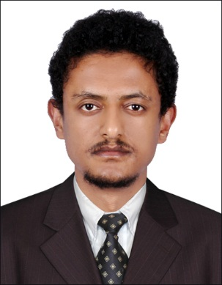
Personal Information
Name Oumer
Year of Birth April 03 1986
Nationality Ethiopian
Marital Status Single
Oumer.363054@2freemail.com

Career Objective
To work with dedication, devotion and meet the expectation of my superior. I shall strive hard and endure my best to enhance the overall development of organization, to excel the area of my activity by taking of challenge assignment at work and contribute to growth of organization by using my knowledge, skill and experience in best possible way through hard work.

Educational Background
- I obtained my College Diploma by Information Technology from National College in 2006.

- Certificate in Information Technology from Higher 4 Middle level Technical and vocation Institute(2003-2004).

- High School 2001-2002 in Ayer Tena Senior Secondary School
- Elementary School 1993-2001 Nesir Private School
Working Experience
- I worked as data operator in the governmental organization called the Federal Democratic Republic of Ethiopia Ministry of Finance and Economics Development Central Statistics Agency from January 31-2008 to july 7-2008
- Now I have worked as Security Guard in Alwatan Security Service (ASS) since November 2012.

Retail Experience
I worked as a Sales Person in my Family’s Isuzu Spare Parts Store in term shows my time management skills and my ability to dealing with a wide range of people effectively , including customers and manufacturers’ representatives .
Working Ability
- Understand customers needs (internal and external)
- Integrate customers services with company culture, Example :- recruitment, training, development and etc…
- Management commitment and understanding .
- Preparing weekly, monthly and yearly report to employees and split them by their qualification and profession.
- File Management.
- Preparing payroll to new employee and for those who took promotion or transfer report it to the branch that concerned.
- Balancing monthly transaction and report to the personnel section head and other job s assigned by administrator
Language
English - Fluent Usage
Arabic - Good
Additional Skills
As I am graduate of Information Technology I have extensive skills in Ms- Office, internet access and general knowledge of computer.
Sales Skills
Working In Family store required both product knowledge and an ability to assess and meet customer needs. This also involved dealing with complaints and enquiries calmly professionally.
Teamwork
Co- Operative project work during academic career required tact, assertiveness and a sense of humor to achieve a successful outcome.
Interests
Reading inspirational books magazines, newspaper, watching movies, reality shows and more

