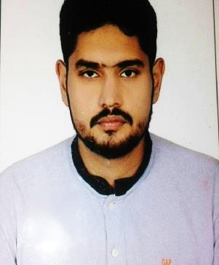

SYED
Syed.363099@2freemail.com

CAREER OBJECTIVE:
An enthusiastic self-motivated individual with excellent inter personal skills the ability to take responsibility & work as a team. Quality & customer focused with the drive to achieve results. To seek a challenging & responsible assignment in a reputable organization, where I apply my current skills & knowledge.

PERSONAL SKILLS:
- Punctual focused and very dedicated to any task given.
- Hard working self-motivating team player.
- Maintain observer’s honesty and loyalty.
- To maintain good public relation.
- Excellent planning and organization skills.
- Excellent communication skills
- Honest & sincere in dealing with customer and colleagues
- Interested to take responsibilities and extra task
- Sincere and Honest.
- Understanding and helpful nature.
- Ability to work in minimum supervision.

WORK EXPERIENCE:
- Company : Liver Pool Security
- Position : Security Guard.
- Period : 19-Oct-2015 to Till Date

DUTIES & RESPONSIBILITIES:
- Obey and follow the rules and laws of the management.
- Be alert and vibrant always.
- Always Punctual and Neat.
- Patrolling the shopping area for periods of time.
- Pro-actively ensuring the protection of merchandise, property and assets.
- Creating a safe and comfortable working environment for employees and visitors.
- Directing emergency vehicles and other traffic if a major incident occurs.
- Responding to emergency situations as they arise.
- Accurately reporting all incidents to senior managers.
- Preventing and detecting offences on site.
- Conducting searches of personnel, vehicles and bags etc.
- Producing written reports.
- Arranging the escort of large amounts of money around the site.

EDUCATION QUALIFICATION:
- FSC Pass , Army Public School and College Attock Cantt, Pakistan ( Aug-2013)

TRAINING SKILLS:
- Department of Protective System Passed from Dubai Police Academy (D.P.S.)

COMPUTER SKILLS:
- Basic Knowledge of MS office and Internet, Email surfing

PERSONAL INFORMATION:
- Gender : Male
- Marital status : Single
- Religion : Muslim
- Date of birth : 16/02/1994
- Language Known : English, Urdu, Hindi,
- Visa status : Employee

HOBBIES:
- Reading, Travelling, Listening music

REFRENCES:
- Available upon request

DECLARATION:
I certify that the above are true and correct to the best of my knowledge and ability. If given a chance to serve you. I assure you that I will execute my duties for the total satisfaction of my superiors.

