ELZOD
Elzod.363114@2freemail.com
Retail Sales Representative
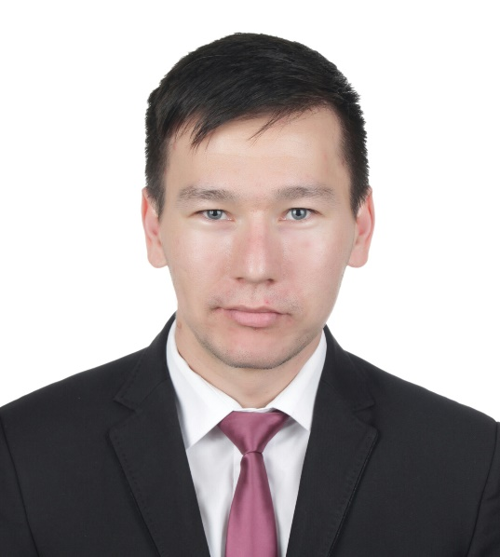  Date of birth:  26/07/1989  Nationality:  Uzbekistan  Current Location:  Dubai, UAE  Languages:  English – fluent  Russian – fluent  Turkish – fluent  German – intermediate  Japanese – intermediate  Uzbek – native  Skills:  Flexible, sociable, friendly and ability of working under pressure and in a busy environment, well knowledge of MS Office (Word, Excel, Power Point, Outlook)  Hobbies:  Craft making, jogging, drawing, playing a piano  Retail Software Awareness:  SAP, Retail-Pro | ACHIEVEMENTS  - Winner of The Watch Boutique Special Award for overachieving the targets, being the best salesman and bringing amount of AED 1,434,500 profit which was number one to the company within 6 months;  - Achieved whole AED 500,000 amount of yearly Seiko brand target and gained the trip to Hong Kong in 2014 and Istanbul in 2016  - Winner of a Mystery shopper report with 105% score by performing high class customer service which is a crucial skill that was learnt in the company training “CUSTOMER SERVICE FROM HEART”;  - Have a valid UAE driving license;  - Captain of the basketball and volleyball amateur team at the university for 3 years and won 2 cups  - Ability of multilingual conversation: English, German, Japanese, Turkish and Russian
WORK EXPERIENCE
Retail Sales Representative since 07.05.2013 in
Al Futtaim Watches and Jewellery (44,000 employees) doing business in almost all sectors of UAE market since 1936 as well as in other GCC countries, Egypt and Pakistan.
(Reference upon request: Retail Operations Manager)
Achievements:
- Developed the business by achieving multiple targets such as, individual, store, line etc.;
- Enhanced the profit to the store than the previous year indicators;
- Increased the regular customers’ list from 33 to 58 people by contacting and offering them the best deals frequently.
Responsibilities:
- Daily counting of stocks which is over 2,000 pieces of watches and tally them up with the quantity in the system;
- Performing customer service from heart to customers and enhance their satisfaction;
- Introducing and promoting products according to a customer’s need using tactical sales technics;
- Always getting the customer feedback after closing the deal.
- Doing admin works with the help of business software such as SAP. Retail Pro etc.
Sales Associate from 03.08.2010 to 07.07.2012 in
Chrono Luxury Watches Boutique (more than 500 employees) dealing with luxury watch brands in the capital of Uzbekistan since 1995.
(Reference upon Request: Store Manager)
Achievements:
- Kept on performing as ATV leader in the store;
- Had a great product knowledge about the brand by taking part of the trainings;
- Increased the regular customers’ list from 33 to 58 people by contacting and offering them the best deals frequently.
Responsibilities:
- Greeted customers and determined their needs and wants;
- Discussed type, quality and number of products required for purchase;
- Recommended merchandise based on individual requirements;
- Provided advice to customers regarding particular products;
- Explained the use and advantage of product to customers;
- Answered customers’ queries and concerns.

EDUCATION
Bachelor's Degree:
Tashkent State University of Oriental Studies
02.10.2007 – 28.05.2011
Major Linguistics
High School Degree:
Shahrisabz Academic Lyceum specialized for computer technologies
2.09.2004 – 25.05.2007

LIFE PHILOSOPHY
A great pleasure in life is doing what people say you cannot do

