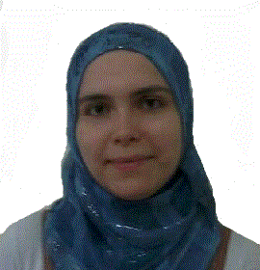
Rawda Rawda.363131@2freemail.com
Personal Information | - Marital status: Married  - Nationality: Syrian  - Age: 29  - Place of Birth: Damascus  - UAE Visa status: Valid UAE residence till 2018
Education | 2009- Present Damascus University Damascus  Studying Master in measurement and evaluation  - My result average is 87 %
2004-2009 Damascus University Damascus
BSC degree in Psychology Counseling
- My result average is 72.4%
Professional experience | 2016-2017 American Schools of creative sciences Sharjah  Social Worker  2014-2015 Brilliant International Private School Sharjah  Psychological counselor for students from KG1 to 8th grade  2013-2014 Alitqan Amirecan School Sharjah  Social worker for students from kg1 to 7th grade  - Registered as approved social worker in the Ministry of education in UAE.  2011-2013 Um Ammar elementary school Damascus  Psychological counselor for the children's in 5th and 6th grade  - Providing assessment and treatment for children as individuals or in a group.  - Keeping in touch with student’s parents to find the best way to solve student’s problems.  - Keeping abreast of developments in theory and research and undertaking continuing professional development (CPD).  2009-2011 Al Anwar Primary Private School Damascus  Psychological counselor for the children in 5th and 6th grade  - Providing assessment and treatment for children who have learning difficulties or special needs.  - Doing entertainment activities with children which help them to develop their knowledge and abilities.  2008-2009 Wahet Al Tofola Private School  Damascus  Teacher for the children in KG1 grade  - Teaching the curriculum for students in simple way  - Applying new theories of teaching
Professional courses | 2007 Prana Damascus  Diploma in Neuro-linguistic programming
2010 Amal organization Damascus
Speech and Language Disorders
Additional professional activities | Attends to the French- Arabic conference for psychologists
Languages | English good reading and writing
Arabic native

Computer Skills | ICDL certified  MS office (Word, Excel, Power point)
Good Internet Navigation

University Project | We have prepared a successful research about the Internet addiction and its relation to the social isolation

