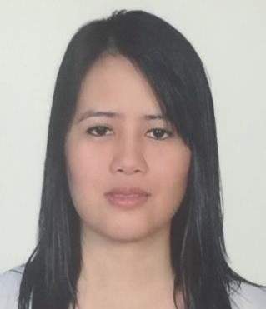
MARY
Mary.363183@2freemail.com

Objective:

- To be able to work for your company, where I could render my services and further
enhance my skills and knowledge in this field.
- To obtain a position that would best fit my capabilities and develop further my knowledge and skills for self-development.
WORK EXPERIENCES:
AL SAGR NATIONAL INSURANCE COMPANY
NON-MOTOR DEPARTMENT (2013 UP TO THE PRESENT) ALAIN U.A.E

- Knowledgeable in preparing and issuing Medical Policies for both Abu Dhabi and Dubai plan
- Proficient about HAAD and DHA regulation
- Issuing Continuity Certificate and Certificate of Coverage (System Generated)
- Advising the client with different option and categories
- Travel Insurance
- Contractor’s All Risk Policy
- Workmen's Compensation Policy
- Fire Insurance and Property All Risk Policy
- Engineering Insurance CAR
- Marine Insurance
- HAAD penalty calculation
- Organized files correspondence and documents
- Monitoring all incoming and outgoing claims files
- Issuing quotations based on the client requirement
- Keeping track of changes in policies terms and condition during the policy period.
- Deal with the clients in good behavior to obtain their truth to deal with us and make renewal to their policies.
- Working independently, making decisions as appropriate with minimal supervision

Al SAGR NATIONAL INSURANCE CO.
Secretary (DEC 2011 to 2013) ALAIN- UNITED ARAB EMIRATES
- Received and screens telephone calls, mails and visitors
- Organized and files correspondence and document
- Handle all incoming calls for general inquiries & information.
- Answering all calls, and communicate requests to the concerned department. Ensure follow-up with all Customer request
- Apply proper etiquette at all times (helpful, professional, maintain calm and composure).Always speak composed and clearly in a polite, business-like manner
- Ensure and maintain the security of information relating to Customer
- Adhere to company policy on confidentiality and ethic
- Perform other related duties incidental to the work described herein.
- To ensure that the Company grooming standards are maintained at all times.
- Performing other job-related duties as assigned by management
- Ensure customer service done 100%

EDUCATIONAL BACKGROUND
2002-2006 PERPETUAL HELP COLLEGE OF MANILA
Bachelor of Science In Nursing
PERSONAL DATA:
Nationality : Filipino
Birth date : 25th of August 1985
Status : Single
Height : 5’5”
Weight : 57kg
Language Known : English and Tagalog

