Christina

Christina.363237@2freemail.com

Career Objective:

HAAD RN
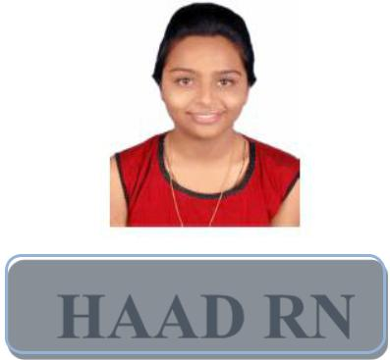

A position as an obstritic healthcare, bringing excellent record of nursing education and training, hands-on emergency department experience and outstanding interpersonal skills to give maximum level of patient care.

Experience:

- Since 01 September 2014 working as Team Leader in Emergency Department at Godrej Memorial Hospital, Vikroli, Mumbai.

Practical Experience Gained During Working Period:

- Admission and orientation.

- Assist doctors for physical examination and other procedures

- Direct patient care including bed making, mouth care, feeding etc.

- Beside IV line insertion, administration of medication and nutrition

- To meet nutritional physiological, social, economical, spiritual and rehabilitation needs of patient

- Investigation and collection of specimen

- Coordination between members of health team and patient

- Management of emergency situation like cardiac arrest

- Receiving and shifting of pre and post-operative patients to the respective wards

- Follow-up care of patients

Type of Patients Attended:

- Myocardial infarction , heart block, unresponsive patient
- Accidents , poisoning.

- Bronchitis, Asthma, ARDS, Tuberculosis.

- Epilepsy, Stroke, Neuropathy, Encephalitis, Meningitis, stroke

- Sepsis , dengue.

- Pulmonary Edema, pneumonia

  - Renal Failure
Page 1

- Hypertension / Hypotension

- Hyperglycemia / Hypoglycemia

- Head Injury

- Cardiac Emergencies like Myocardial Infarction, Left Ventricular Failure, Arrhythmias, Conduction Abnormalities, Sudden Cardiac Arrest

- Pre-eclampsia, Eclampsia, Normal / Caesarean delivery

- Surgical cases like Tonsillectomy, Hernia, Amputation

- Surgical emergencies like Appendicitis, Perforation Peritonitis, Ectopic gestation.

Equipment’s Handled:

- Scope and its processer.

- Ventilator

- Defibrillator

- Syringe pump

- ECG machine

- Glucomerter

- Pulse oxymeter

- Bipap

- DVT pump

Specialized Procedures Attended:

Assist endoscopy and ERCP, intravenous insertion, central line insertion, cardio pulmonary resuscitation, emergency management of cardiac arrest, pleural tube removal, bladder catheterization, stomach wash, peripheral line insertion, blood transfusion, assisted intubation etc.

Academic Qualification:

- Maharashtra State Board – SSC in the academic year March 2007

- Maharashtra State Board – HSC in the academic year February 2010

- BSc Nursing from Hirnandani College of Nursing – Powai – Mumbai

  - First Year BSc Nursing passed during 2011 with 59.57%

  - Second Year BSc Nursing passed during 2012 with 66.28%

  - Third Year BSc Nursing passed during 2013 with 74.33%

  - Final Year BSc Nursing passed during 2014 with 72.40%

Special Achievements:

Page 2

- Winner of Dosabai Godrej-Naoroji Award for compassionate care 2016 on Education and Mentoring.

- Participated in AHPI global conclave and being winner for the criteria “Patient Friendly Hospital”

- Passed HAAD Licensure Examination for Registered Nurse 30 March 2017

Computer Skills:

- MS Office – Word, Excel, Power Point, Paint Shop, Outlook Express, Internet Explorer etc.

Strengths:

- Capable of handling responsibilities and ability to work in a team.

- Excellent communication and presentation skills.

- Willingness to listen and learn.

