CAREER HISTORY:

________________________________________________________________________

Alban.363247@2freemail.com

Safety Supervisor

Kosovo

May 5. 2013 – Feb. 2. 2017

Duties and Responsibilities:
◊ Supported the HSE Manager and team with planning, coordinating and implementing of effective HSE policies, guidelines and procedures to ensure that the department objectives are met.
◊ Provided support to Project and Operation team in all aspects of safety, occupational health, safety and environmental issues.
◊ Assisted with developing HSE plans that comply with Company policies and procedures as well as client requirements
◊ Ensured training, tool box meetings and drills are implemented as part of the company’s offshore training and HSE program, i.e. emergency response systems, etc.
◊ Investigated and completed the process for close out of all Accident Investigation Reports and prepared/submitted lessons learned to the Regional HSE Manager for promulgation to the management
_____________________________________________________________
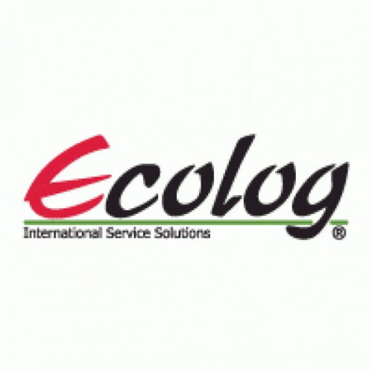
Health and Save Environment Supervisor
Afghanistan
July 9. 2012 – Feb. 15. 2013

Led 70 workers daily.
◊ Assigned to the HSE Manager and team with planning, coordinating and implementing of effective HSE policies, guidelines and procedures to ensure that the department objectives are met.
◊ Developed support to Project and Operation team in all aspects of safety, occupational health, safety and environmental issues.
◊ Attended pre-job, planning and client meetings as required on HSE related matters.
Conducted:
▬ training,
▬ tool box meetings, and
▬ drills are implemented as part of the company’s training and HSE program, etc.
________________________________________________________________________
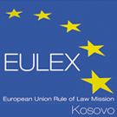
HR Generalist
Kosovo
Oct. 29. 2008 – July 5. 2012

Duties and Responsibilities:
► Responsible for the development, implementation, policies, processes and procedures, staffing, scheduling and other HR administrative functions.
► Assisted Local National employees in resolving basic human resources issues.
► Coordinated Local National hiring process; included preparation of Employment Agreements, Badge/ID paperwork, Job Announcements.
► Created and maintained new hire and personnel files and entered them into Human Resources Information Systems.
► Supported processing and maintenance of payroll records in accordance with policies and procedures, as necessary.
► Wrote employee manual covering issues including disciplinary procedures, code of conduct, FMLA policy and benefits information.
________________________________________________________________________
Guard Supervisor
Kosovo
May 3. 2007 – Oct. 24. 2008
Led 50 workers.
■ Supervised that Standard Operational Procedures (SOP) are met, concerning:
Fire Plan,
Bomb Incident Procedures,
Evacuation Plan,
Emergency Response Procedures,
Rules and Regulations.
________________________________________________________________________
Interpreter/Translator
Kosovo
Dec. 3. 2002 – Sep. 29. 2006

Assigned for U.S. Army, where:
Translated different types of: documents, reports, letters, laws, decrees, court documents, administrative decisions, instructions, procedures, regulations, constitutions, from Albanian to English and Serbian and vice-versa.
________________________________________________________________________
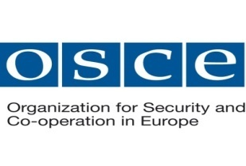
Security Technician
Kosovo
June 16. 1999 – Nov. 29. 2001

Duties and Responsibilities:
- Provided functional and administrative support for Security operations and personnel as assigned.
Assisted with:
♠ investigations,
♠ audits.

- Supported Security management in evaluating and improving security training, security awareness, residential security, office and project security, airport security, secure vehicular movement and route selection, counter surveillance and threat assessments.

EDUCATION:

________________________________________________________________________
- College Student, studying: ECONOMICS/Bachelor. Branch: Banks & Finance.
- Completed High School, ECONOMICS.

CERTIFICATES & AWARDS:
________________________________________________________________________
- “Writing and Managing of European Union Projects” held on: Oct. 24-25. 2013.
- “Leadership Training” held on: Oct.28. 2012.
- “Health and Safe Environment Field Fundamentals” held on: Nov. 5. 2012.
- “Health and Safe Environmental Advanced Skills Workshop” held on: Nov. 6. 2012.
- “Health and Safe Environmental Coaching” held on: Nov. 6. 2012.
- “Fall Protection” held on: Nov. 6. 2012.
- “Electrical Safety” held on: Nov. 6. 2012.
- “Health & Safety Workshop” held on: April. 26-27. 2011.
- “Hostile Environment Security Training” held on: June 27. 2010.
- “Adult Cardio Pulmonary Resuscitation (CPR) and First Aid Training’’ held on: May 25. 2009.
- “Basic Security in the Field – Staff Safety, Health and Welfare”.
- “Physical Security Officers Training Course”.
- “MS Excel 2000 Level 1” held on: July 9-11. 2007.
- “MS Excel 2000 Level 2” held on: Sep. 18-20. 2007.
- “Certificate of Appreciation” by TRW.
- “Certificate of Appreciation” by NGMS.
- “Certificate of Appreciation” by US Army.

LANGUAGES:
________________________________________________________________________
Speak Write Read Understand
ALBANIAN Advanced Advanced Advanced Advanced
SERBIAN Advanced Advanced Advanced Advanced
ENGLISH Advanced Advanced Advanced Advanced
ARABIC Beginner Beginner Beginner Beginner

COMPUTER SKILLS:
____________________________________________________________________________________________________________
- Operating Systems : MS-DOS, Windows all Editions.
- Networks : Windows 2000 Server, Novell Netware.
- Accessories : Word, Excel, PowerPoint, MS Access.
- Software Packages : MS-Office, Adobe Photoshop.

ADDITIONAL INFO:

- Ability to drive manual and automatic vehicle’s shift gear.
- Posses National/Country Driving license since 1997.

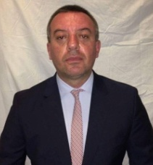
Personal Details:
Name & Surname: Alban
DOB: 18/03/1974
Gender: Male
Country: Republic of Kosova
Nationality: Kosovar
------------------------------------------------------------------------------------------------------------
______________________________________________________________________________________

OBJECTIVE:

________________________________________________________________________
Over 18 years’ worked within different Companies/Organizations, in fast-paced environments. Guaranteed customer service excellence and successful project completion. Flexible in shifts and working hours.
An organization that provides me the opportunity to apply my:
► Health, Safe and Security Supervision,
► HR rules and regulations,
► Managerial and Operational decision making,
► To develop professionally, innovative and workable solutions to the problems that might be faced by Organization/Company.

SUMMARY:
________________________________________________________________________
Key Skills:
■ Sales.
■ Health, Safe and Security Environment.
■ Operations and Logistics (Warehouse, Transportation/Driving).
■ HR/Admin.
________________________________________________________________________

Major Skills:
- ORGANIZATIONAL LEADERSHIP.
- MANAGEMENT.
- COLLABORATIVE.
- INTERPERSONAL ABILITIES.

REFERENCES:
________________________________________________________________________ Available upon request.
-------
I certify that the statements made by me in answer to the foregoing questions are true, complete and correct to the best of my knowledge and belief.

