MOBIN.363257@2freemail.com
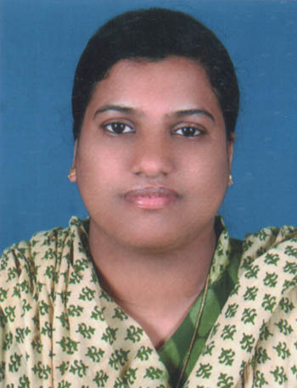
MOBIN

hadd – rn passed on : 16/02/2017
TOTAL YEAR OF EXPERIENCE : 7 YEARS
Professional Qualification

Qualification | Institute | Year
Diploma in Nursing | Vydehi Institute of Medical Science and Research Centre | 2007
Academic Qualification
Qualification | School/College | University | Year
SSLC | St. Teresas G.H.S. Nedukunnam, Kottayam, Kerala | Department of General Education, Kerala State, India | 2002
Plus Two | St. John’s The Baptist H.S.S, Nedukunnam, Kottayam, Kerala | Board of Higher Secondary Examination, Kerala | 2004

Current Registration
Details of registration in the Home Country
Nursing Registration
Karnataka State Nursing Council

Employment and Experience Details
Name of Institutions | Positions | Duration | Ares Worked
Zion Hospital and Research Centre,  Kammanahalli main Road,Bangalore | Staff Nurse | 17-04-2012 to  31-08-2016 | Worked in Emergency Department
Apollo Hospital, Opp. IIM, Bannerghatta Road,  Bangalore | Staff Nurse | 01-12-2008  to  02-01-2011 | Worked in Emergency Department
Vydehi Institute of Medical Science and Research Centre, Bangalore | Staff Nurse | 02-10-2007  to  01-11-2008 | Worked in Emergency Department
Training Programme Attended
- ACLS ,BLS
DUTIES AND RESPONSIBILITIES:
- Assessment, Planning, Implementation and evaluation of the nursing care requirements of their allocated patients.
- Share professional knowledge and skills with all colleagues.
- Demonstrate nursing procedure and supervise junior nurses and student nurses and Para-nursing staff
- Organization and management of nursing care.
- Maintain the core values of the profession.
- Efficient recording of all necessary documentation.
- Timely identification and communication of any issues to ward manager.
- Maintain an effective interdisciplinary communication process.
- Participating in all ward and hospital nursing communication processes.
Equipment Used | Procedures Carried out
- Infusion Pumps  - ECG Machine (12 Leads)  - Pulse Oximeter  - Cardiac Monitor  - Defibrillator  - Nebulizer  - Suction Apparatus  - Glucometer  - Ventilators  - Baincircute  - Incubator  - warmer | - CPR  - Injections  - IM  - IV  - SC  - IV canulation  - Blood Transfusions  - Introducing Nasogastric Tube  - Introducing Foley's Catheter  - Wound dressings  - Elastic Bandage Applications  - Suture removal etc.

LANGUAGES KNOWN: Malayalam, English, Hindi and Kannada
COMPUTER LITERACY: Medicine Intending, Investigations Billing
HOBBIES: Reading to keep knowledge updated. Computers and Internet, Listening to music and watching TV.

MY STRENGTHS:
- Dedicated and patient focused with proven strengths in acute patient care, staff development and family advocacy.
- Exceptional capacity to multitask
- Outstanding interpersonal and communicational skills, superior accuracy in patient history, charting and other documentation.

Declaration

I hereby declare that the above furnished details are true and correct to the best of my knowledge and belief.

