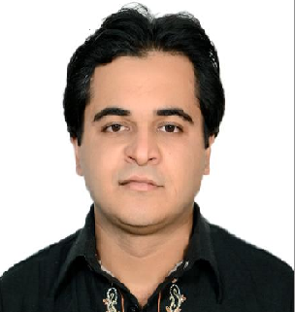

ZEESHAN

ZEESHAN.363278@2freemail.com

Career Objective | Having an inspiration to work with full commitment in your organization with a chance of reasonable growth and to be efficient enough to produce optimally and developed expertise.
Skills | - Coordination skills  - Confidentiality  - Strong work ethics  - Communication skills  - Solutions oriented  - Time management skills.  - Organized with the ability to prioritize and multi-task  - Reliable with patience and professionalism  - Team management and leadership
Experience | Warid Telecom ( Jan 2014- Feb2017)  Customer Service Agent  Responsibilities:  - Improve customer service experience, create engaged customers and facilitate organic growth  - Take ownership of customers issues and follow problems through to resolution  - Set a clear mission and deploy strategies focused towards that mission  - Develop service procedures, policies and standards  - Keep accurate records and document customer service actions and discussions  - Analyze statistics and compile accurate reports  - Recruit, mentor and develop customer service agents and nurture an environment where they can excel through encouragement and empowerment  - Keep ahead of industry’s developments and apply best practices to areas of improvement  - Control resources and utilize assets to achieve qualitative and quantitative targets  - Adhere to and manage the approved budget  - Maintain an orderly workflow according to priorities  Tameer Micro-finance Bank Limited(TMFB), (Feb2012– Dec2014)  Relationship Officer  Responsibilities:  - Ensure full awareness of all products provided and is constantly updated on all changes and amendments on product features, procedures and processes.  - Promote Bank products by providing consistent, accurate and transparent information to customers.  - Achieve sales targets assigned and contribute to the overall achievement of the team.  Maximize on cross selling growth of existing customer base and identify new potential selling opportunities  - Follow up and close selling/cross selling lead referrals.  - Pro-actively participate in bank products campaigns & promotions  - Ensure that all service levels and agreements are being met consistently without any fail  - Participate in-house training programs and workshops  - Attend product training, presentations and road show events.  - Ensure that bank policies and guidelines are consistently & strictly followed  - Comply with committed turnaround times and laid down procedures.  Tameer Micro-finance Bank Limited(TMFB), (March2010– Jan2012)  Sales Executive  Responsibilities:  - Visit potential customers for new business  - Provide customers with quotations  - Negotiate the terms of an agreement and close sales  - Gather market and customer information and provide feedback on buying trends  - Represent your organization at trade exhibitions, events and demonstrations  - Identify new markets and business opportunities  - Record sales and send copies to the sales office  - Review your own sales performance
Education | - Bachelors in arts (Graduation), Punjab university 2007 - 2009  - Intermediate, Lahore board of intermediate 2003 - 2005  - Matriculation, Lahore board of intermediate 1999-2001

