​CURRICULUM VITAE
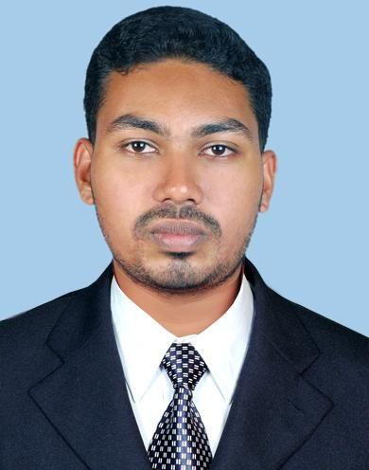

SHIHAB

Al Quoz, Dubai, UAE

E-mail: shihab.363288@2freemail.com

OBJECTIVES:

To pursue a challenging career predominantly in Graphic Designing that exploits my ability to the maximum, while providing sufficient exposure responsibilities.

SUMMARY OF PROFILE:

● Graphic Designing

EDUCATIONAL QUALIFICATIONS:

- Plus Two

- Diploma In DVM (Digital Visual Media)

COMPUTER SKILLS:

- Graphic Designing (Photoshop, Illustrator, Indisign )

- Web Designing (Dreamweaver , Macromedia Flash 8)

- Video editing (Premier pro)

- 3D Modeling and Animation (Maya,3Ds Max)

- Visual Effects (Discreet Combustion)

- Interior Designing (AutoCAD, 3Ds Max)

PERSONAL DETAILS:
Age & Date of Birth | : | 27, 08-12-1989
Sex | : | Male
Marital Status | : | Single
Religion & Caste | : | Islam, Muslim
Nationality | : | Indian

LANGUAGES SKILLS:

- ​English, Malayalam​,Hindi​ and Arabic

WORK EXPERIENCE:

● Red Moments​(​Emotions Unlimited)
​July 2011 - Sept. 2014, Ernakulam, India

​Use the Adobe Creative Suite to design corporate gifting designs for printing on mugs, cloths, stones, ceramic tiles, tempered glasses etc.

● Golden Neon L.L.C

​Octo. 2014 - Present, Al Quoz, Dubai, UAE

Use Illustrator and Photoshop to design signage and big scale printing graphics.

CNC Plotter cuting ( Vinyl sticker cuting )

STRENGTHS:

- Self​ Confidence

- Team Player

DECLARATION​

The above mentioned information is true and correct to the best of my knowledge and belief.

Place: Dubai | ​ SHIHAB.
Date:

